

**IHCI First Project Submission**

**Project Group: A_G3_P2**

**HCI Group No: 3**

**Group Members:**

* 2024187: Dhruv Agarwal (Group Leader)
* 2024168: Daksh Kumar
* 2024111: Arsh Ahluwalia
* 2024150: Bhavay Yadav
* 2024130: Aryan Rana
* 2024205: Divyeh Chaturvedi

**Requirement Gathering**

* **Mental Model**
* **Use-Case Diagram**
* **Google Form and Interview Analysis**
* **Personas**
* **Scenarios**
* **Problem Understanding & Brainstorming**
* **Identifying Challenges and Requirements**

**(Links for all the resources are attached at the end)**

**Mental Model**

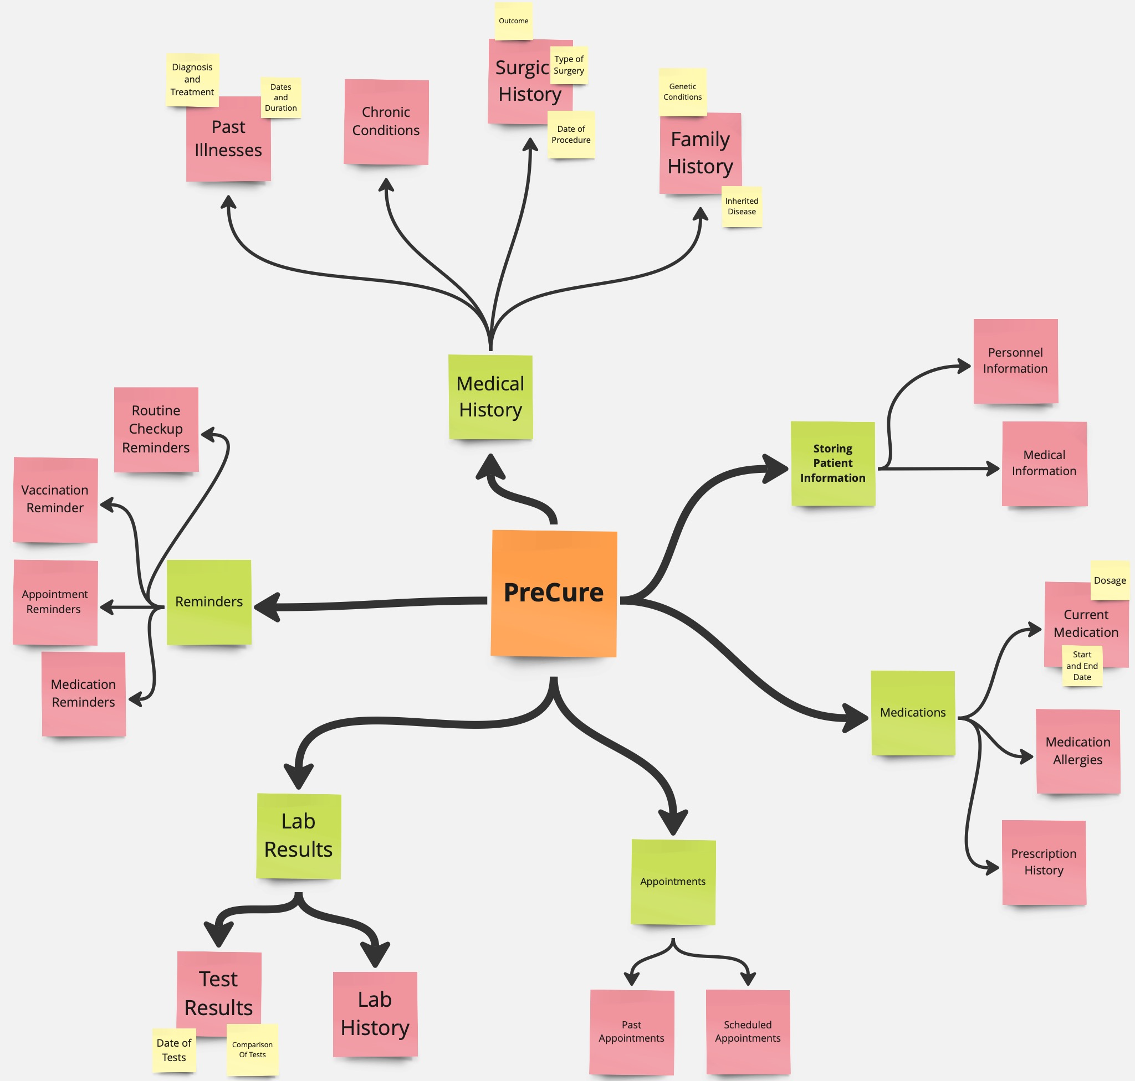

**Use Case Diagram**

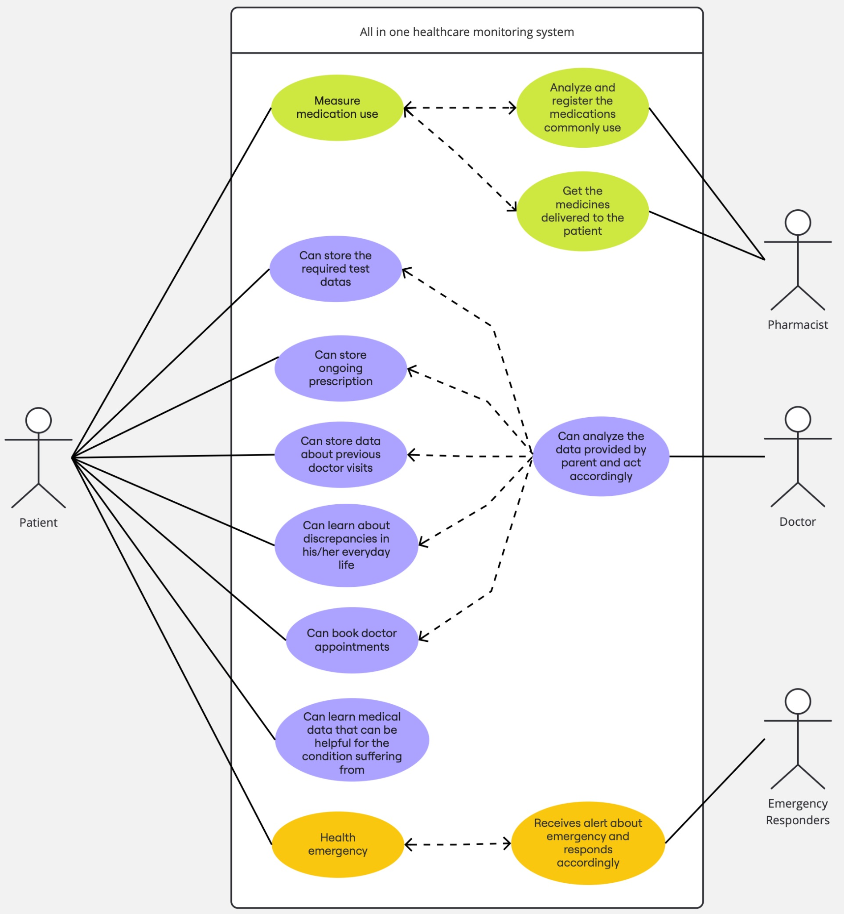

**Google Form and Interview Analysis**

* General Introductory Questions

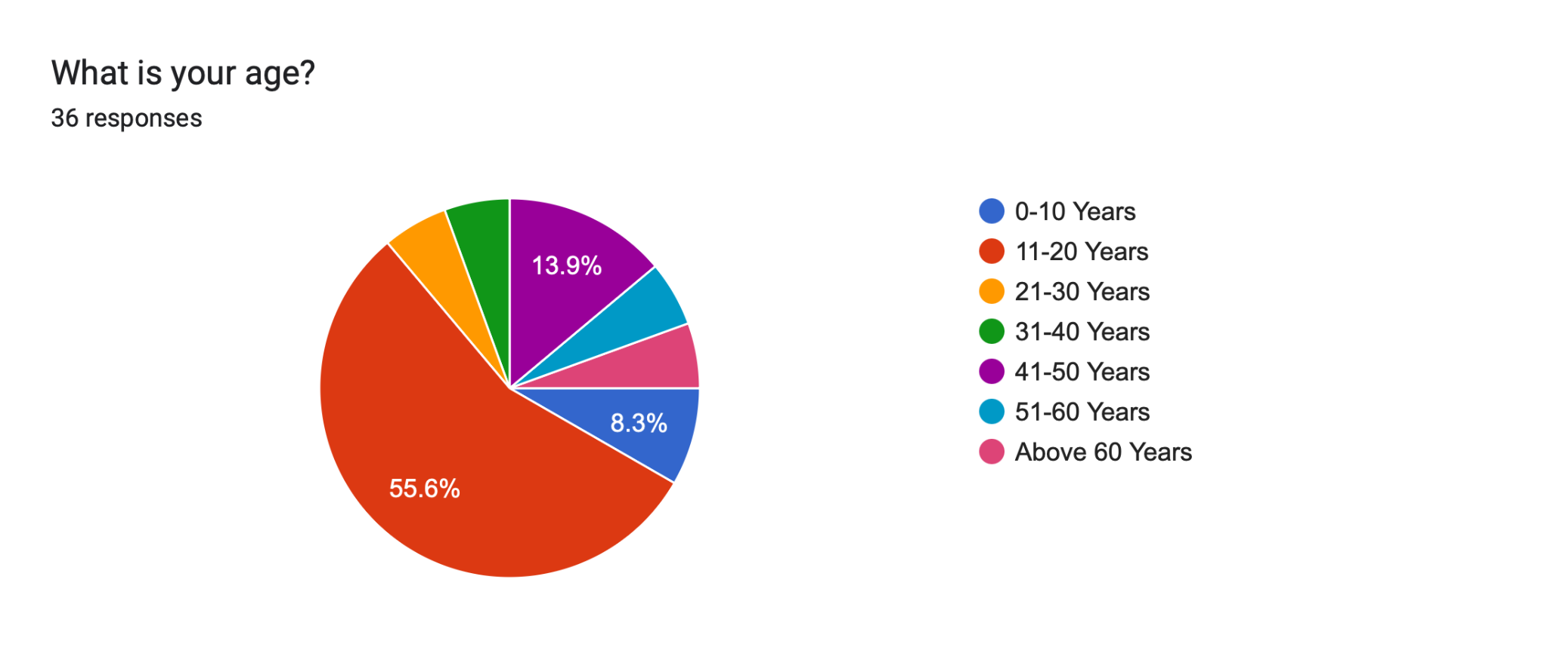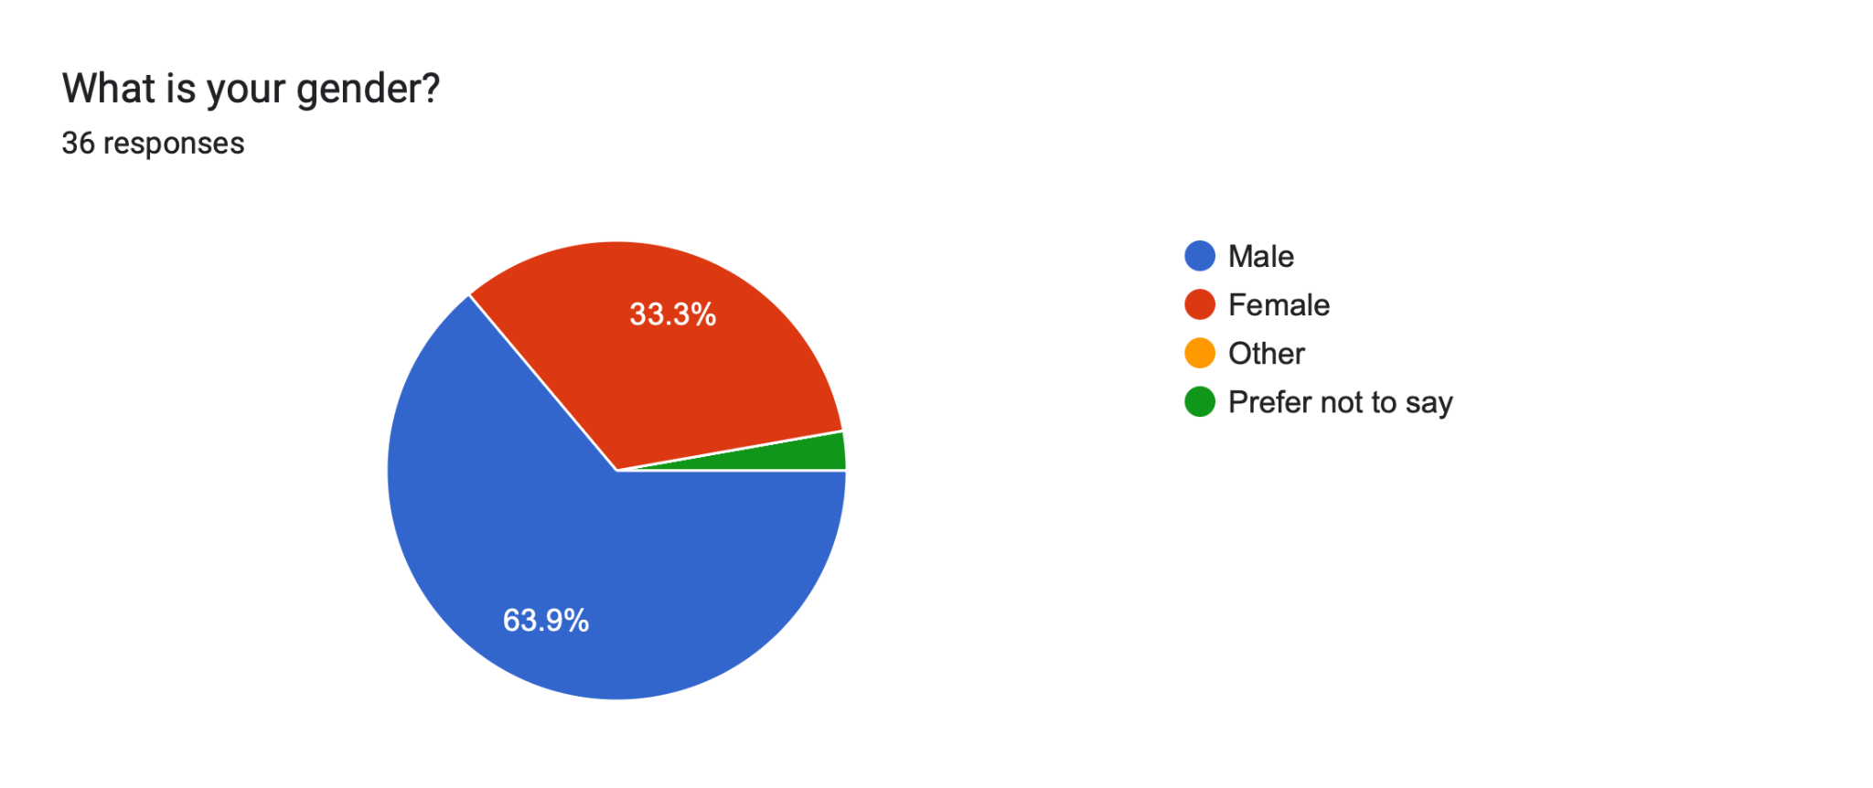

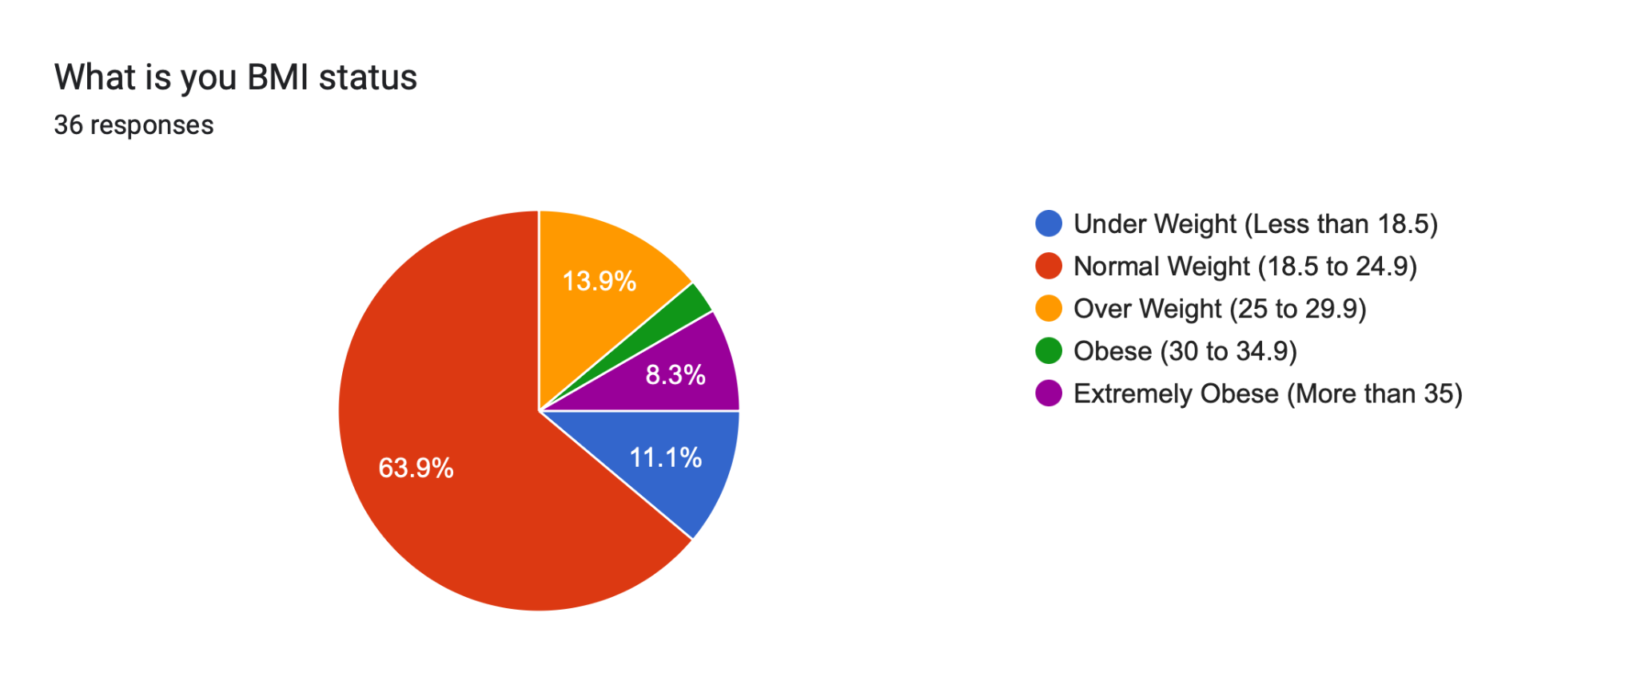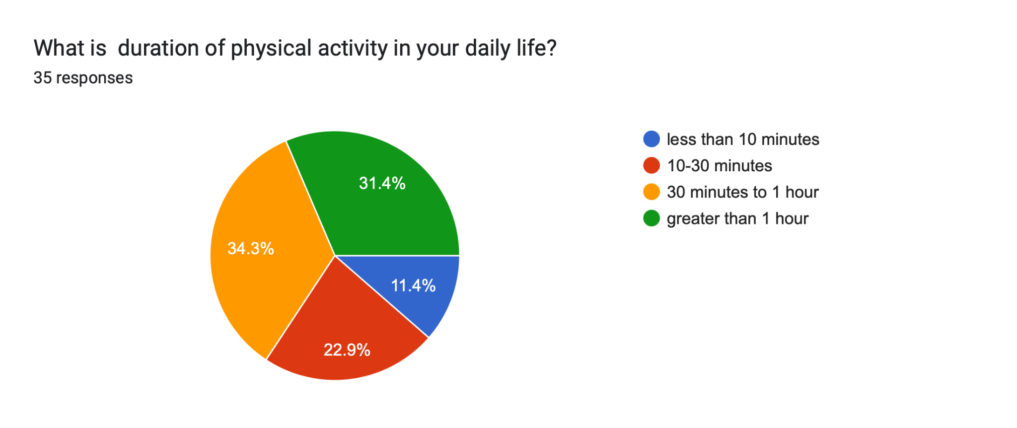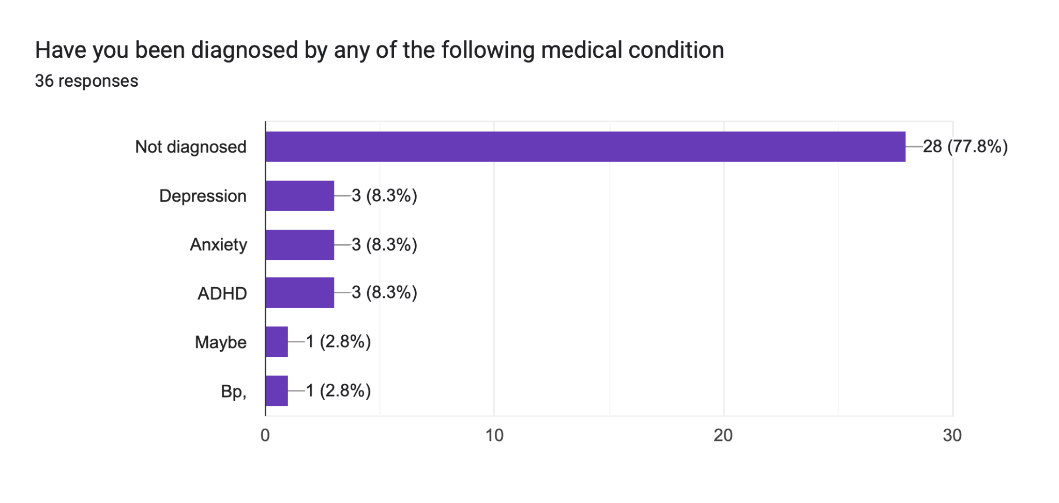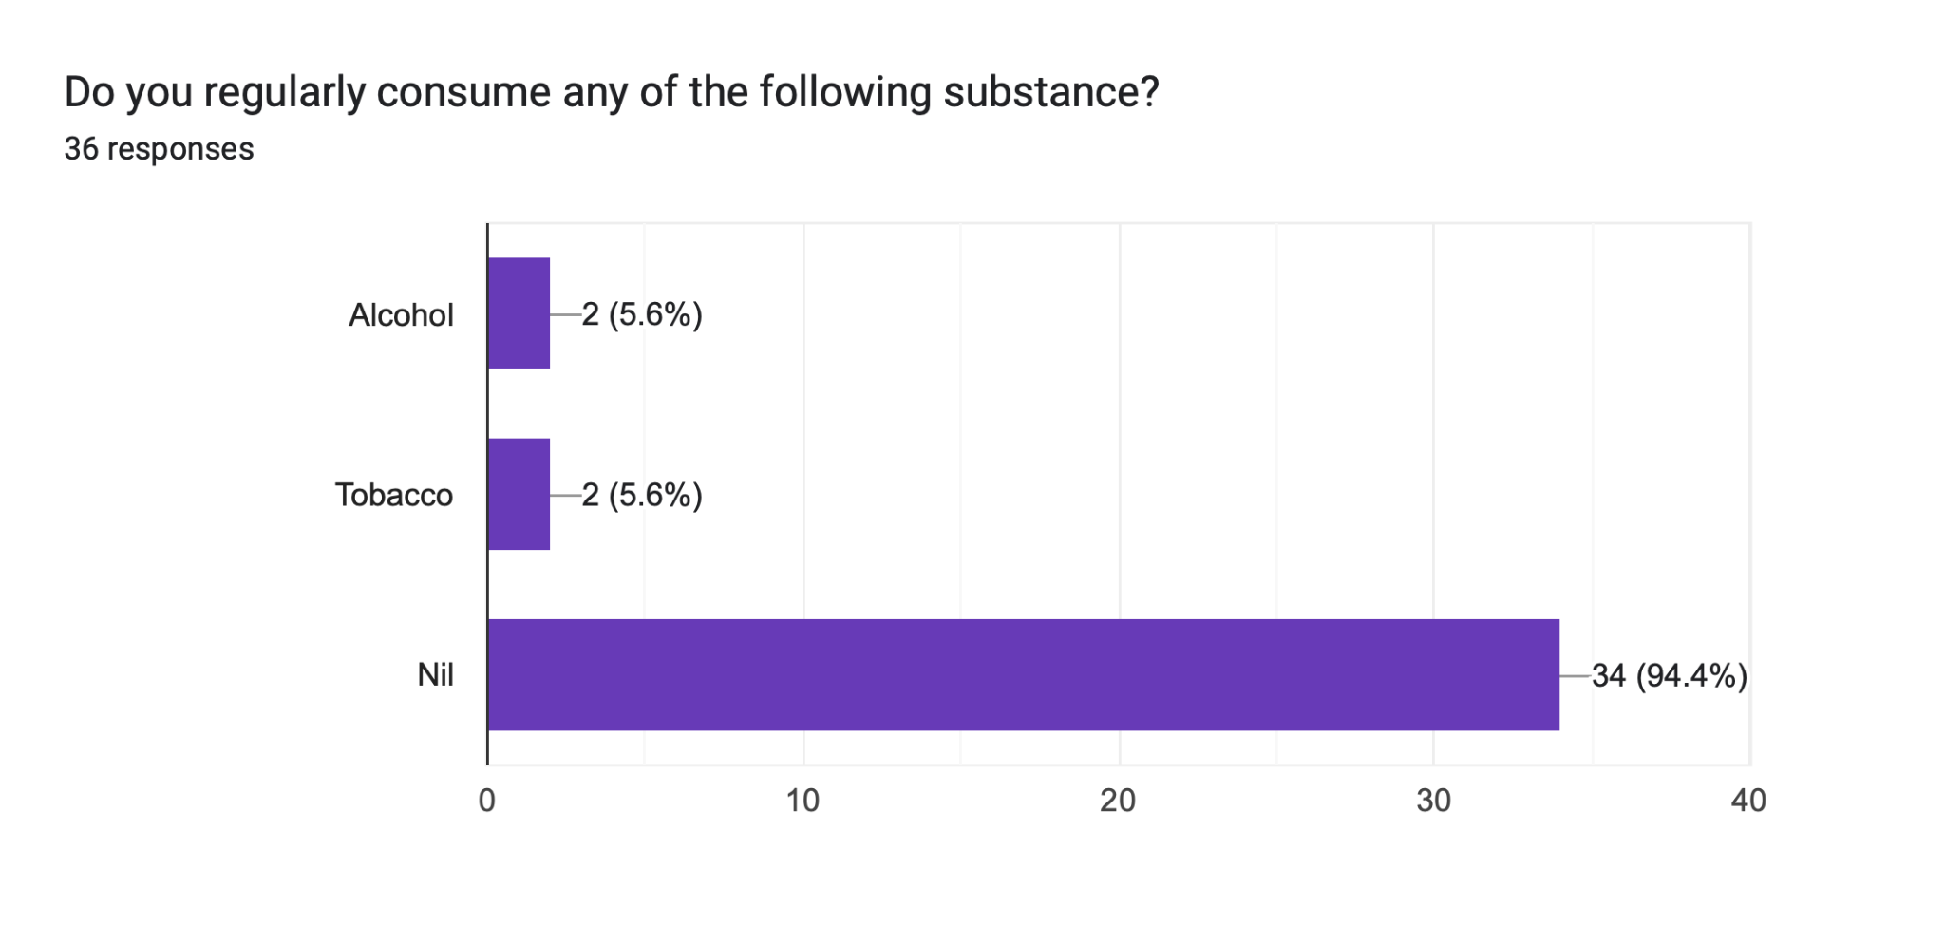

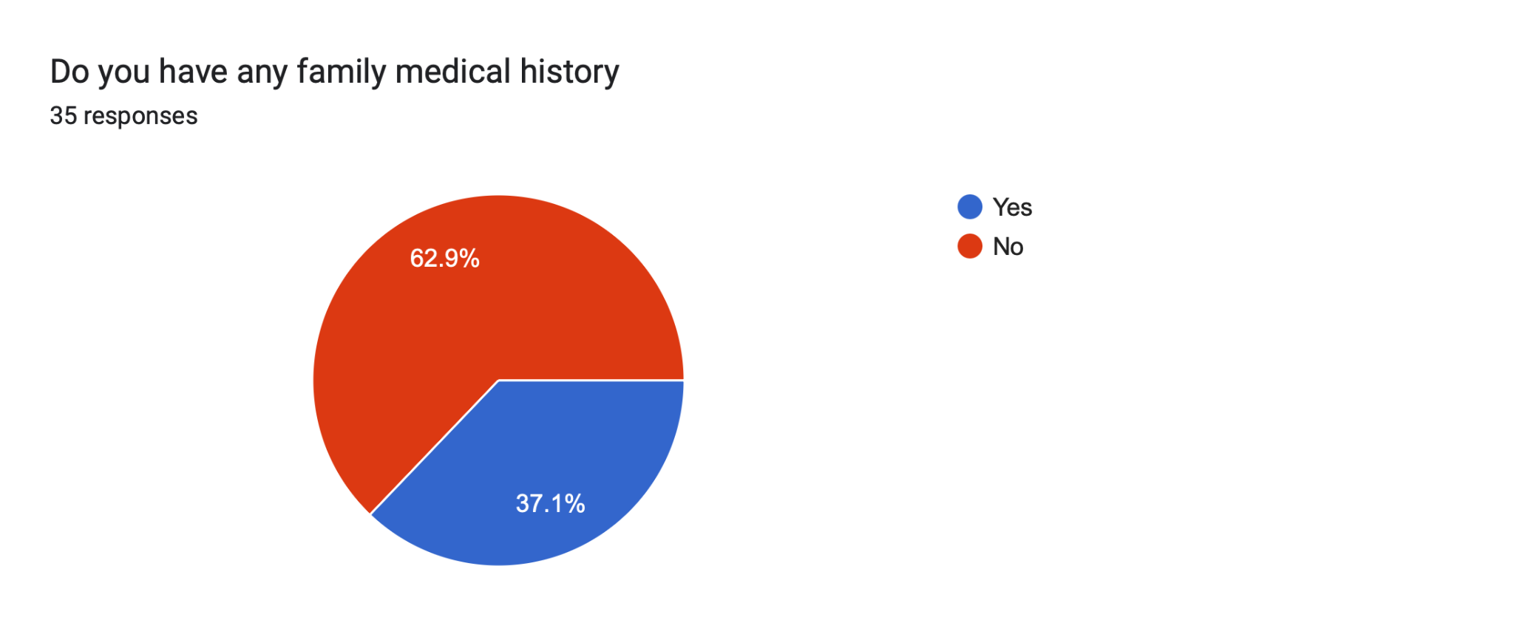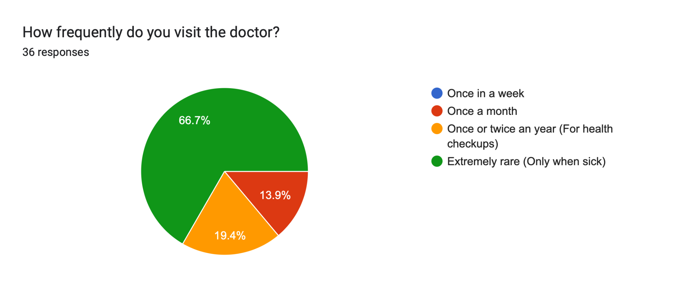

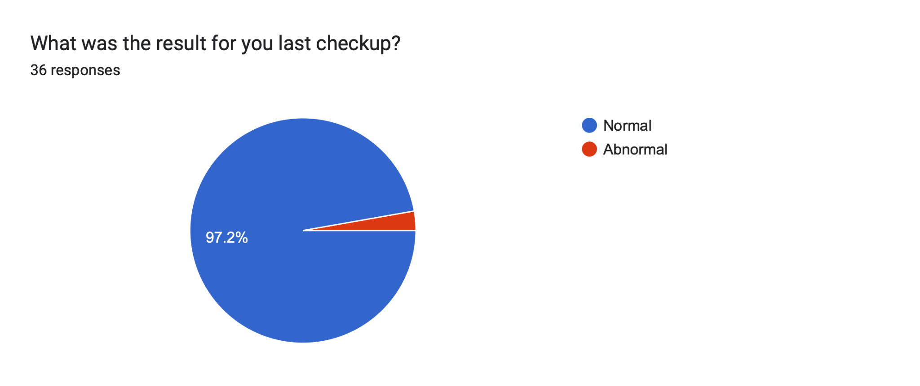

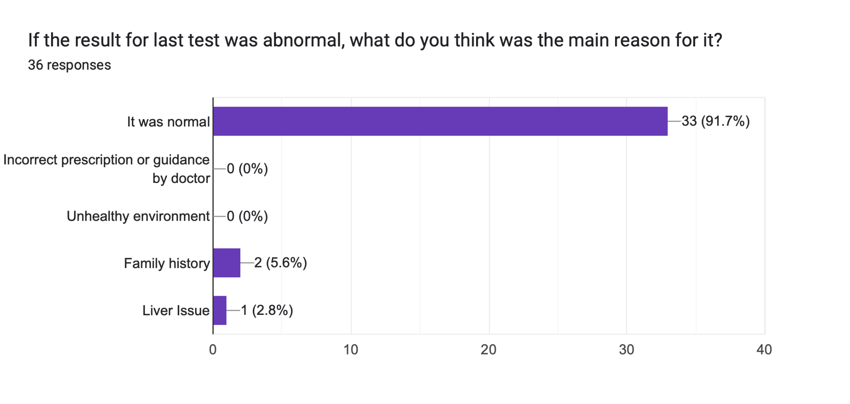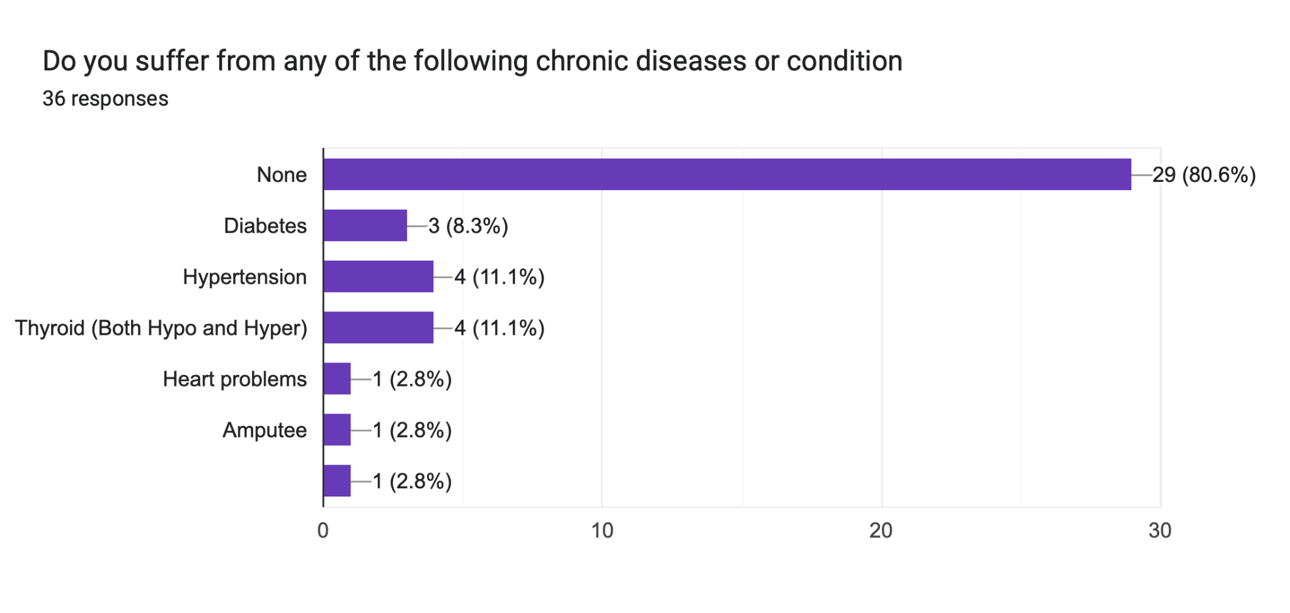

* Interview with a Doctor

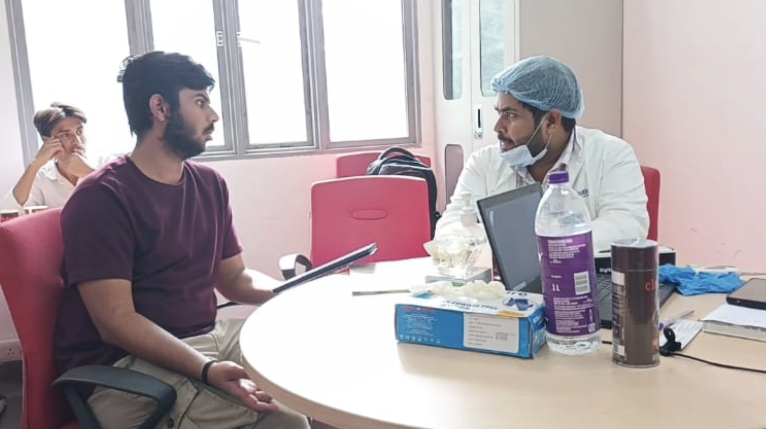

* Important Questions Regarding the Application

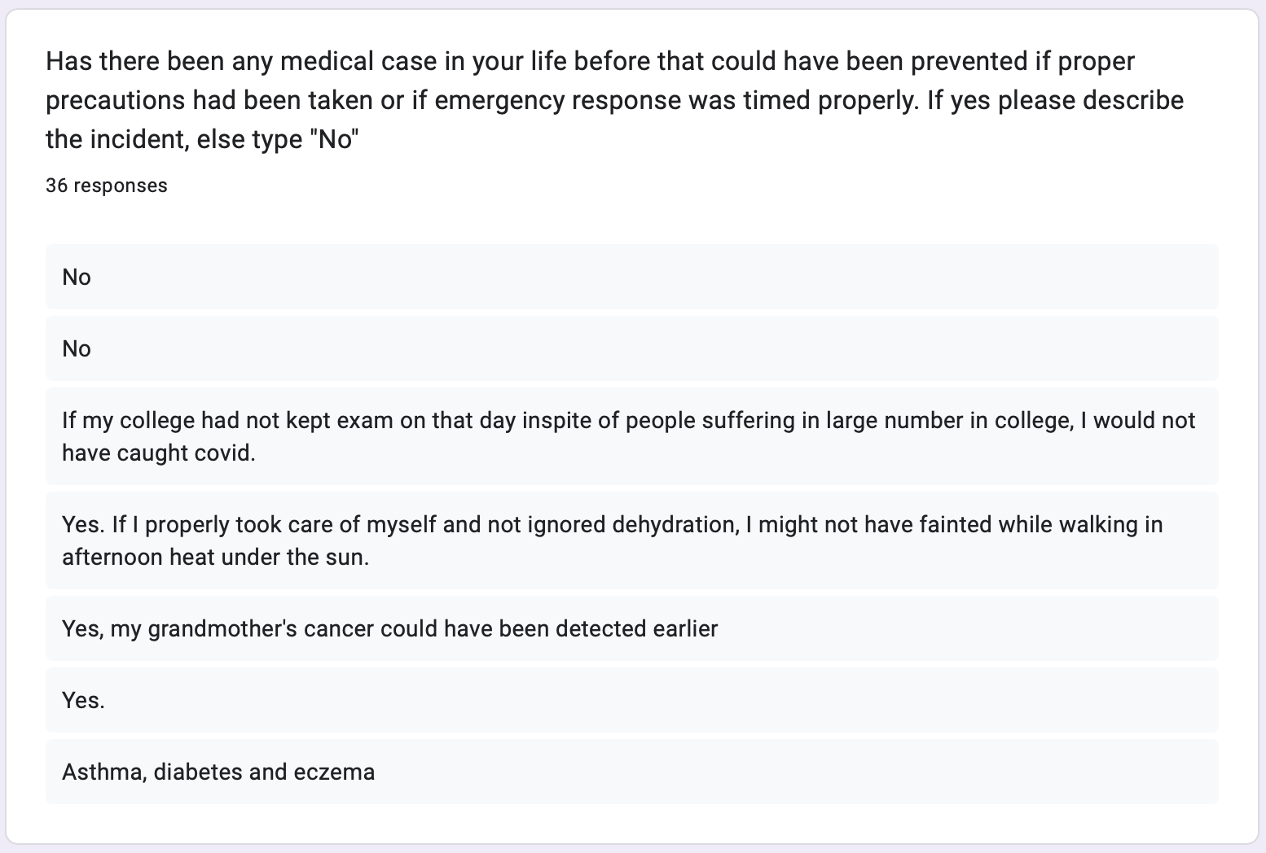

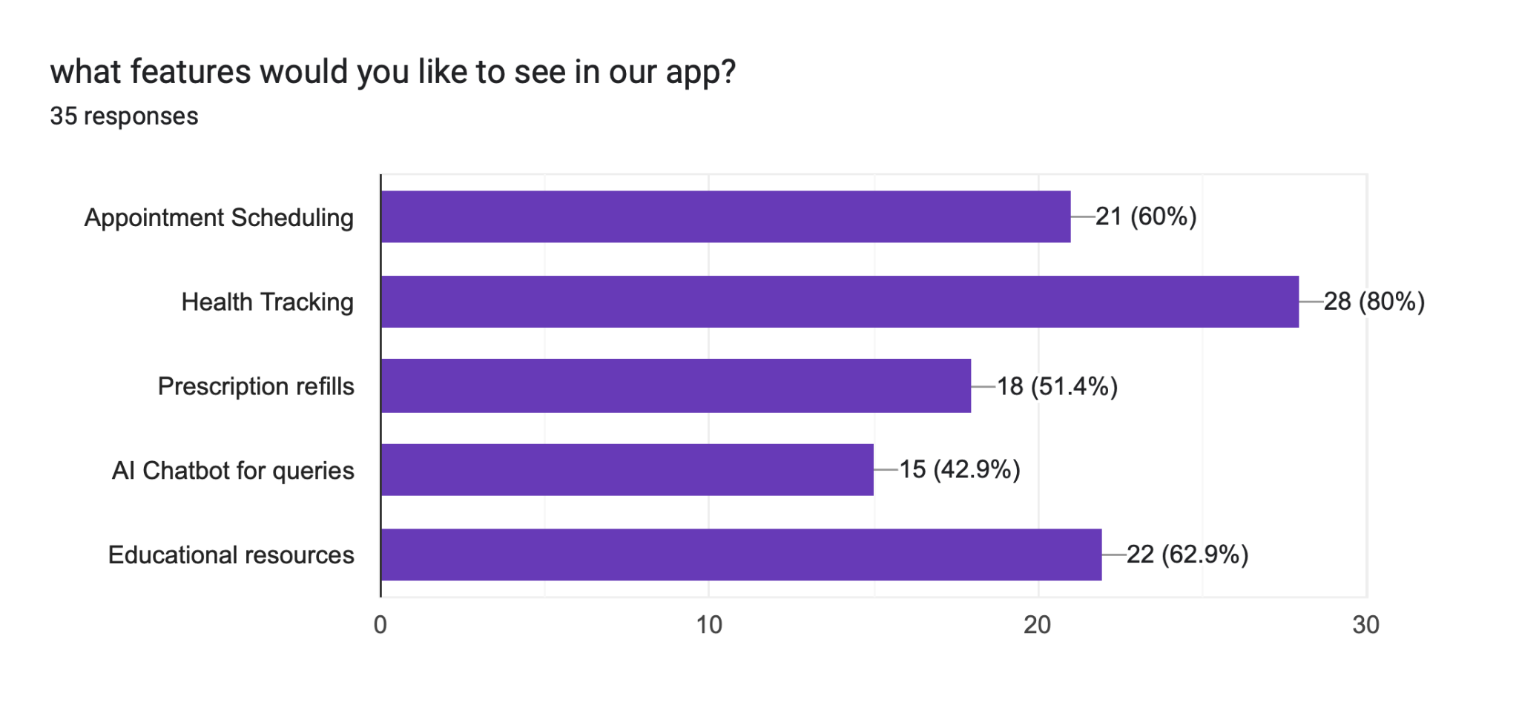

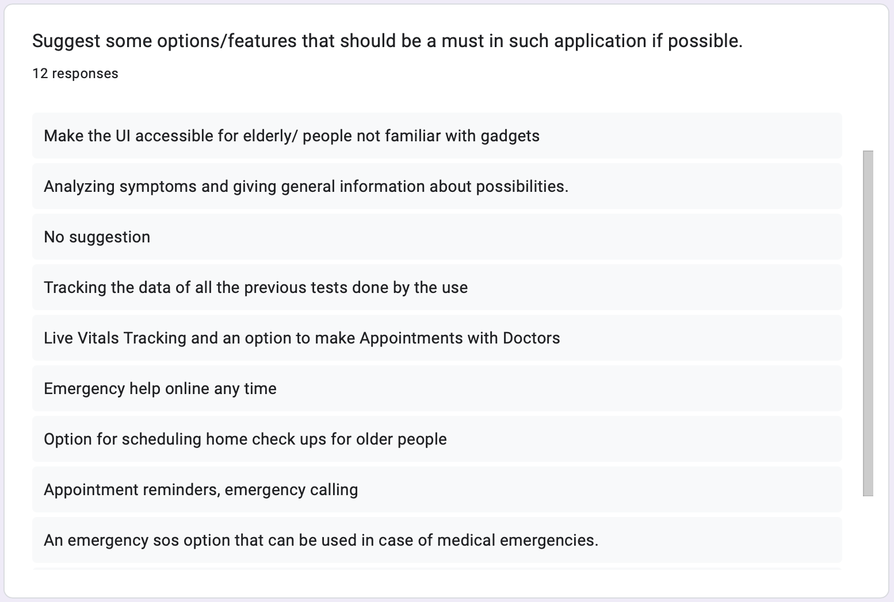

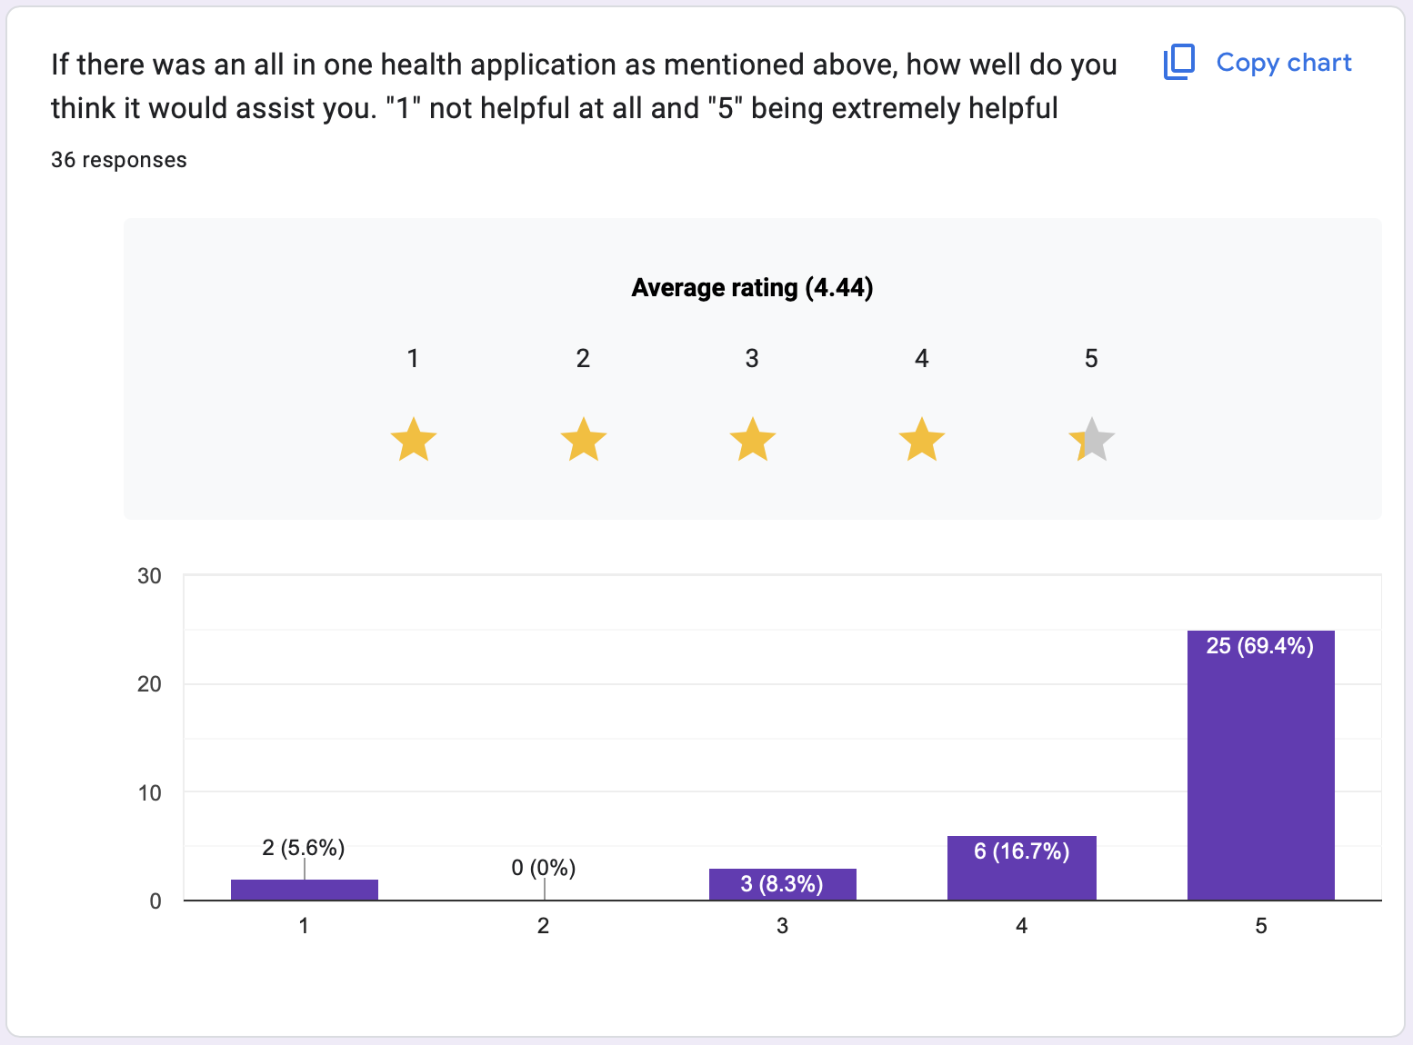

* Analysis of Survey & Interview
* Common conditions include **ADHD, anxiety**, **depression,** and **hypertension**, while many respondents are **not diagnosed** with any major conditions. This diversity highlights the need for an app that can address mental health, chronic conditions, and general wellness.
* Some respondents are **managing chronic diseases** such as **diabetes, hypertension, and thyroid problems**, though the majority **do not suffer** from chronic conditions. This shows that while chronic disease management is important, general health monitoring remains a priority.
* Most respondents have **a normal weight BMI (18.5 to 24.9)**, with a few individuals being **underweight, overweight, or extremely obese**. This suggests that while many respondents are in good physical condition, the app must cater to those managing weight-related issues, as well.
* **Physical activity** varies widely, with some individuals engaging in **over an hour of exercise,** while others report **less than 10 minutes**. The app should incorporate fitness-tracking features that cater to both active users and those looking to increase physical activity.

The ***features most commonly desired*** by respondents include:

* **Appointment Scheduling**: Many respondents expressed a need for an easy way to schedule appointments, showing a desire for convenient access to healthcare providers.
* **Health Tracking:** Respondents want a way to track their health metrics, likely related to weight, physical activity, and chronic conditions.
* **Prescription Refills**: Some users seek the ability to manage their prescriptions easily through the app.
* **AI Chatbot for Queries**: The ability to ask health-related questions in real time is seen as a valuable feature.

**Personas**

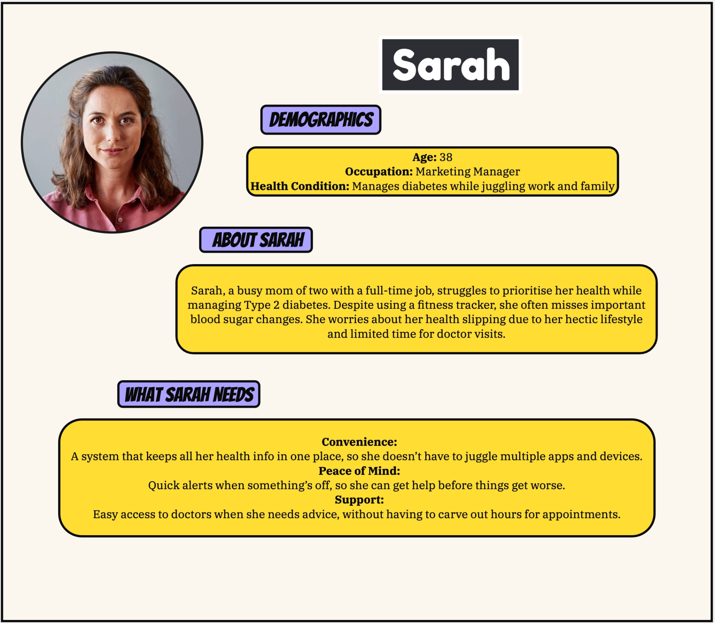

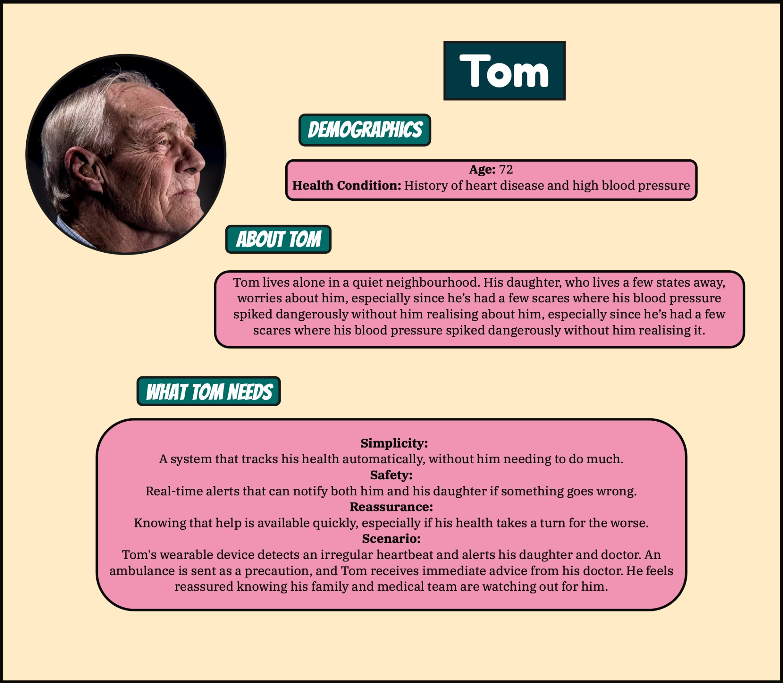

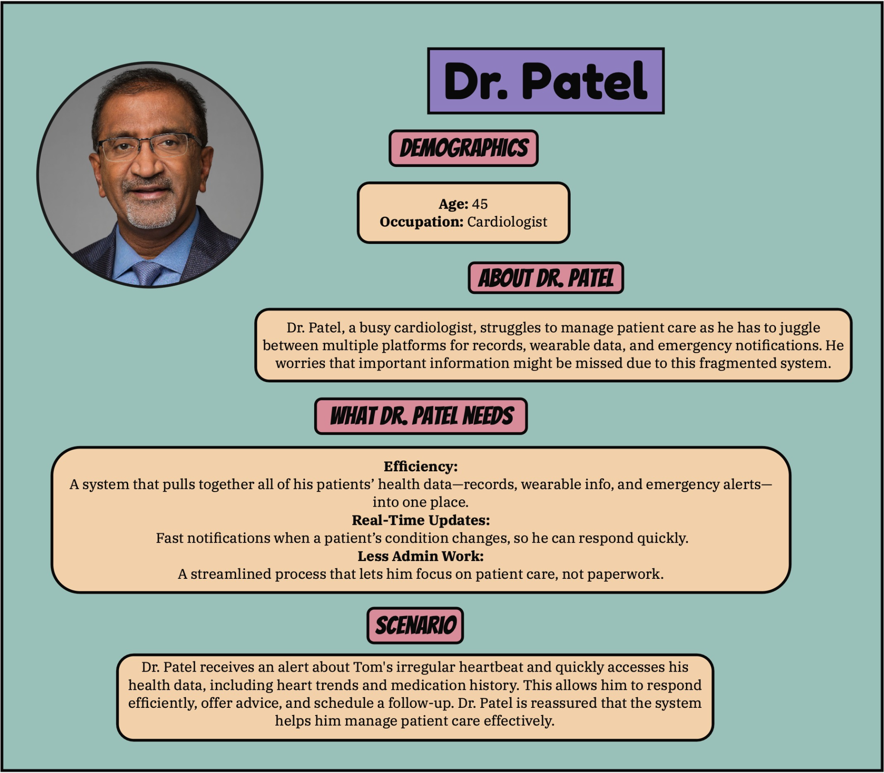

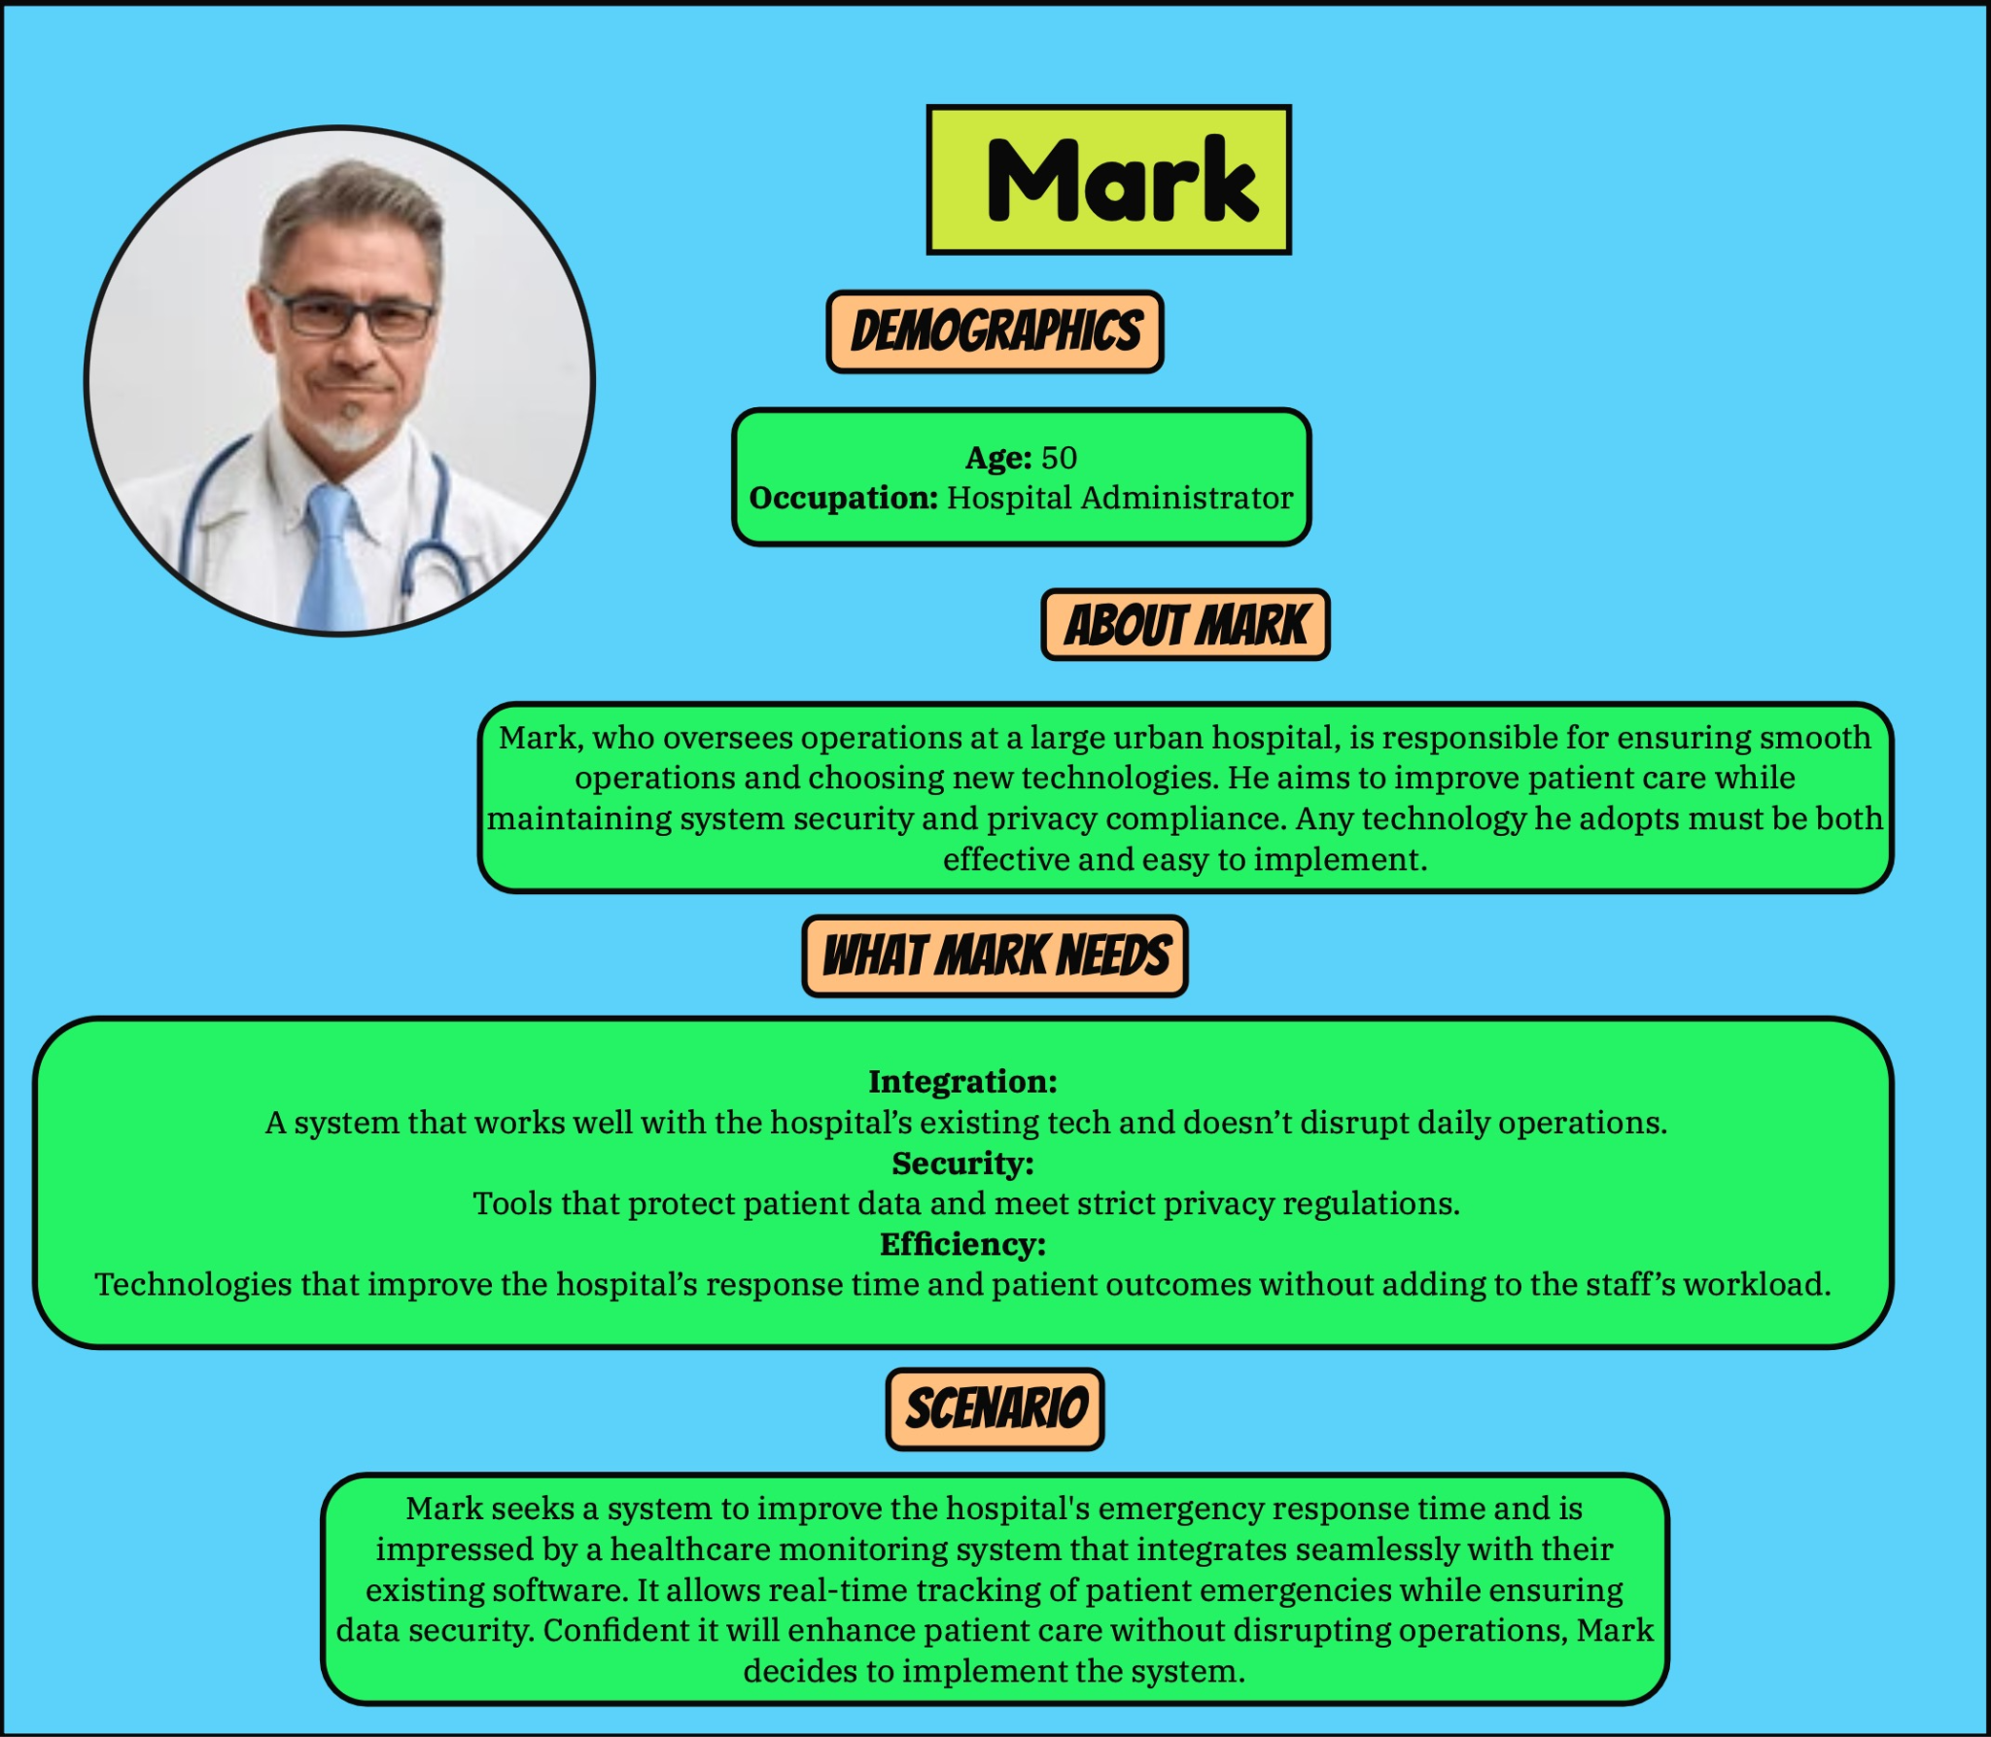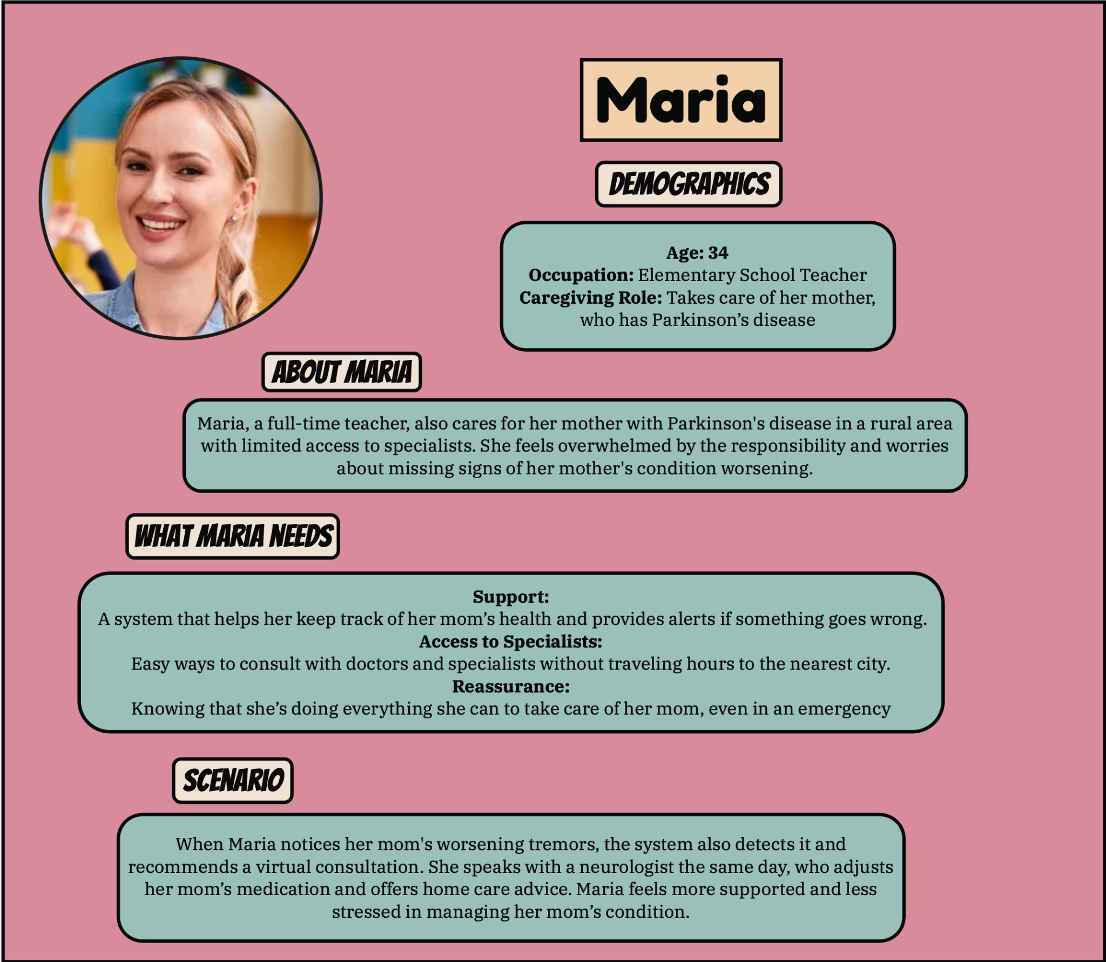

**Scenarios**

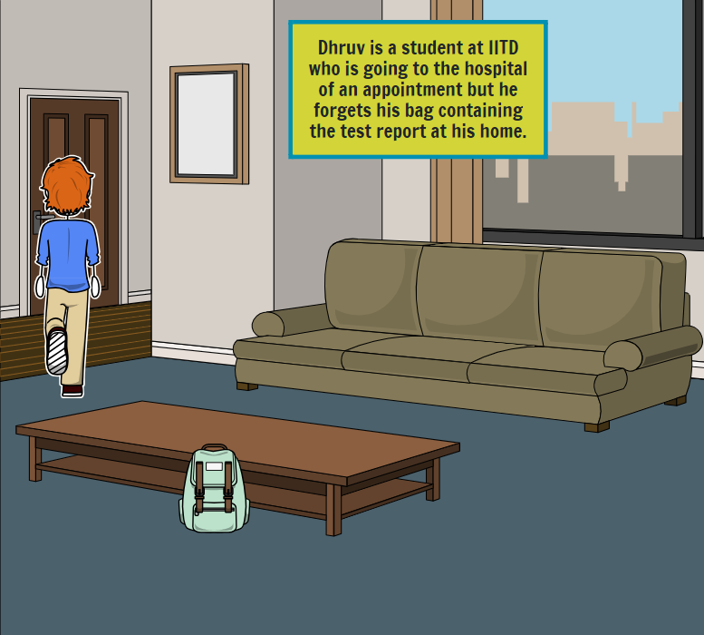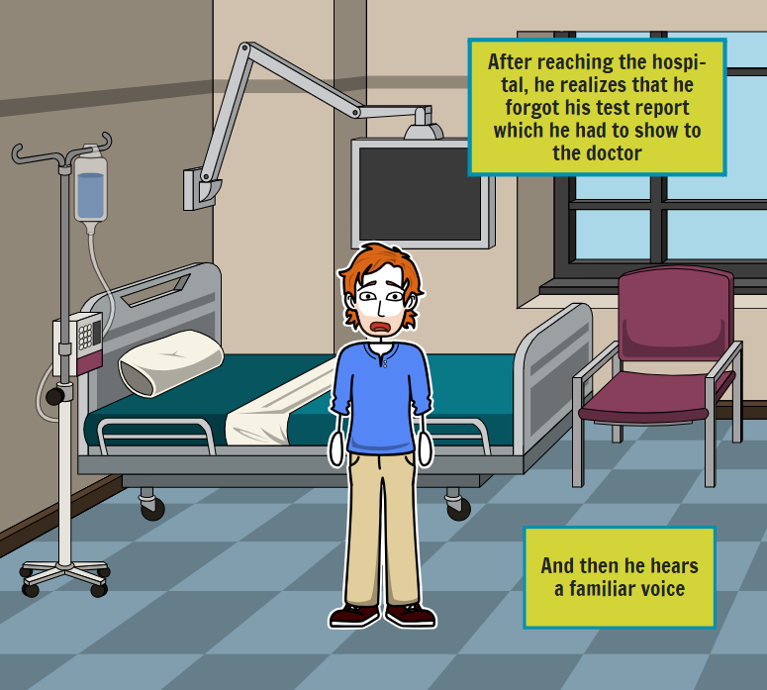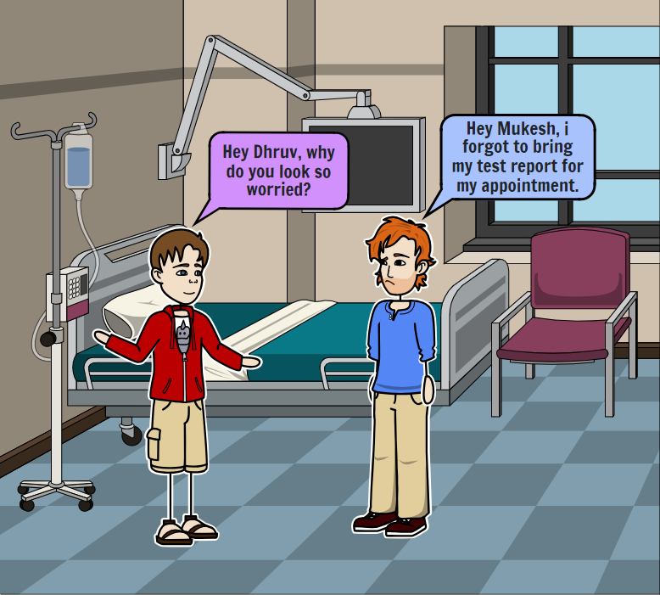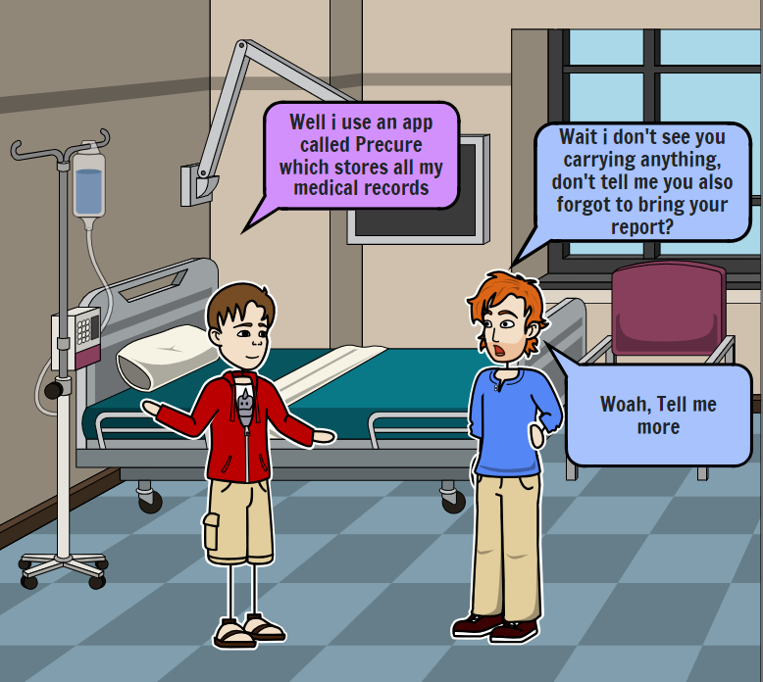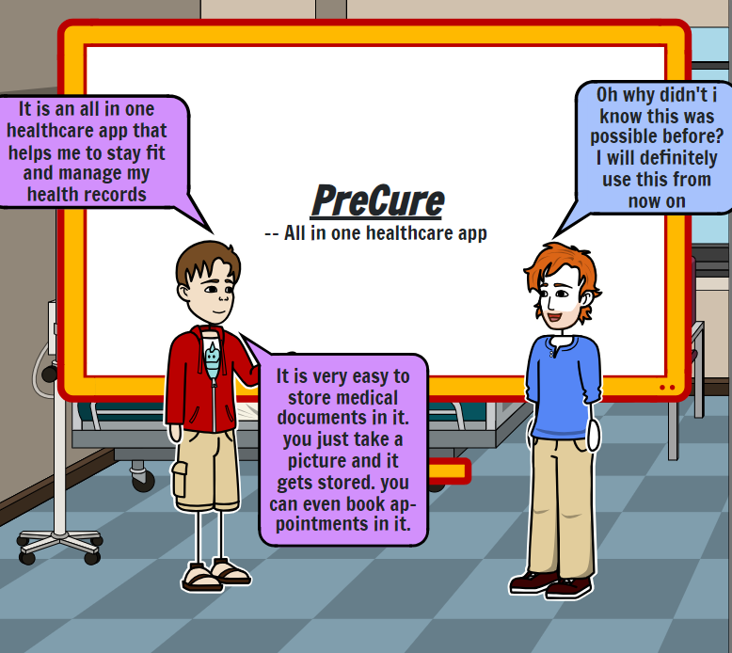

**Problem Understanding & Brainstorming**

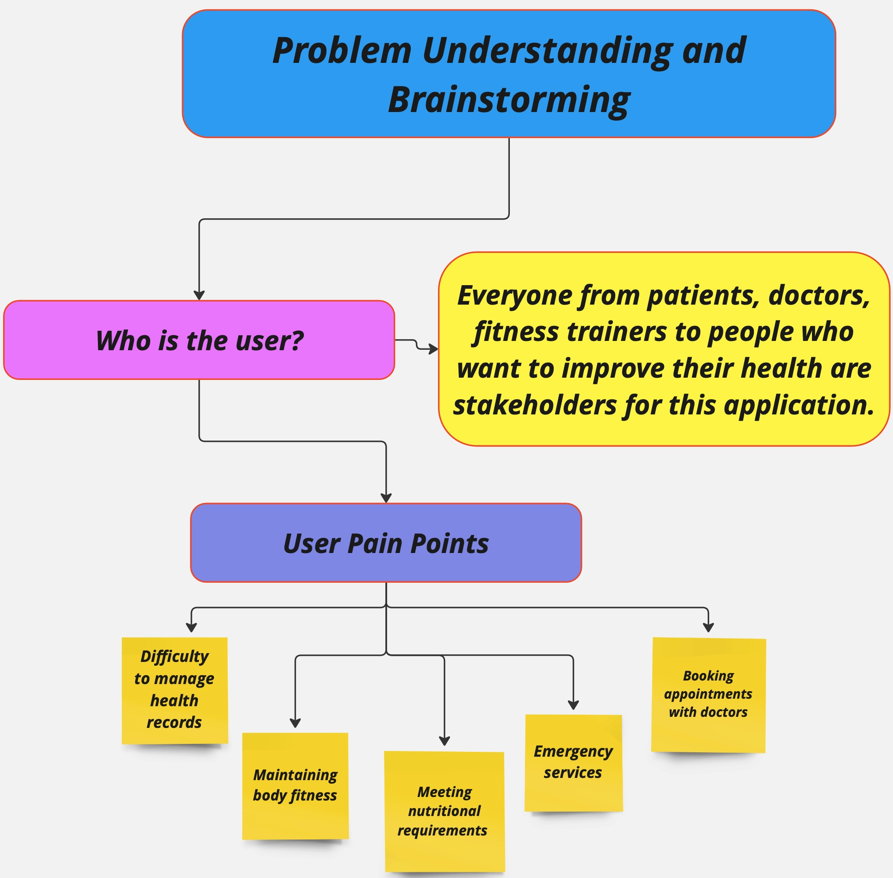

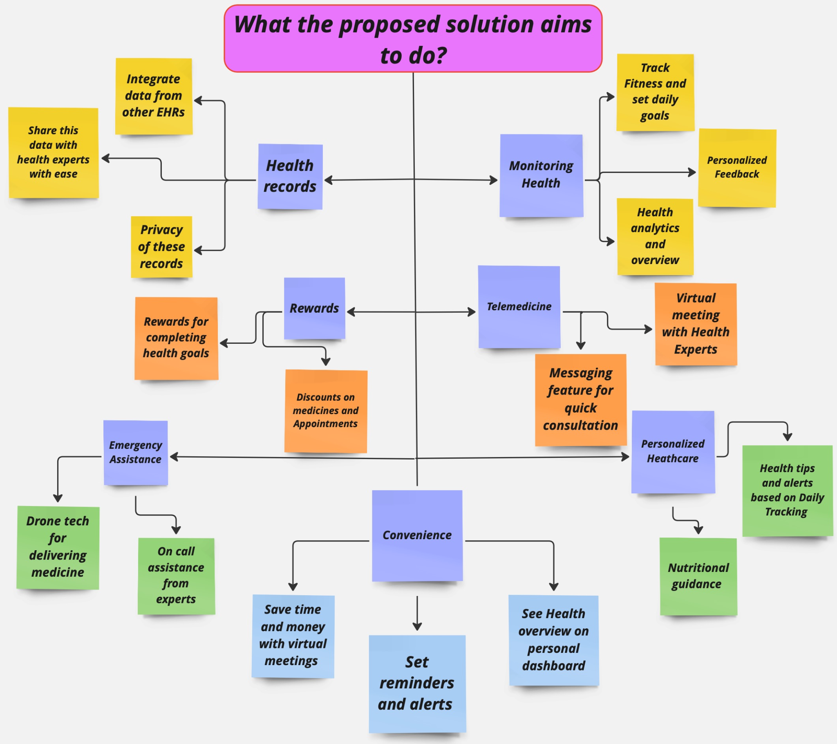

**Identifying Challenges & Requirements**

**1. Requirement Gathering**

* Finding stakeholders: Identifying the right people was tricky, especially with unclear roles.
* Unclear expectations: Understanding stakeholders may not know what they want or have conflicting needs.
* Communication gaps: Misunderstandings arose from unclear explanations between group members.
* Limited access: Scheduling conflicts made it tough to get everyone's input.
* Tool frustration: Using unfamiliar softwares slowed down our process.

**2. Personas and Scenarios**

* Guessing too much: Initially,lack of individual data lead to unrealistic personas.
* Bias: Personal biases led to distorted personas, which were then modified.
* Too broad/narrow: Some personas were either generic or overly specific.
* Missing diversity: Overlooking different user perspectives made personas look incomplete.
* Time-consuming: Creating personas took more time than expected.

**3. Problem Understanding**

* Hard to define the problem: Narrowing down the issue was tricky.
* Misalignment: The team had an internal disagreement on the core problem faced by our target users.
* Not enough user research: The solution may miss the mark without proper user insights.
* Assumptions: Unvalidated assumptions lead to poor understanding, which lead to poor results in the beginning.

**4. Low-Fidelity Designs**

* Design struggles: Not everyone on our team was confident in sketching and wireframing.
* Confusion over layout: Designs initially were unclear and misunderstood.
* Lack of iteration: Time constraints limited design revisions.
* Feature disagreements: Team members had a disagreement on which features matter most.
* Unpolished ideas: Our early designs lacked detail.

**5. Low-Fidelity Testing and Testing Methodology**

* Unclear testing approach: Choosing the right testing method was challenging.
* Limited feedback: Not enough users and wrong testers weakened our results.
* Misreading feedback: Feedback was misinterpreted by one of our members.
* Time-consuming: Testing and applying feedback took us longer than expected.
* Bias: Testers on our team gave overwhelmingly positive feedback.

**6. Alternate Design**

* Resistance to change: Teams resisted major revisions.
* Overcomplication: Trying to fix too much lead to complex designs from one of our team members.
* Creative block: Coming up with new ideas was difficult.
* Insufficient feedback: Feedback lacked detail, making revisions tough.
* Time pressure: Tight deadlines limited time for redesigns.

**7. Contributions**

* Unequal workload: Initially, some team members had less work which was fixed through mutual agreements during our meetings.
* Role confusion: Unclear responsibilities lead to overlap or missed tasks in the beginning.
* Coordination issues: Scheduling and workflow coordination were challenging.
* Conflicting ideas: Disagreements slowed down our progress.

**Lo-Fi, Testing & Alternate Designs**

* **General Task Flow of application**
* **Lo-Fi Design(Hand Drawn Sketches)**
* **Mid-Fi Design(Wireframes on Figma)**
* **Features Implemented(Said and Inputs from Survey)**
* **Mid-Fi Testing Feedback Analysis(Google Form)**
* **Alternate Mid-Fi(s) (Final Design)**

**General Task Flow of Application**

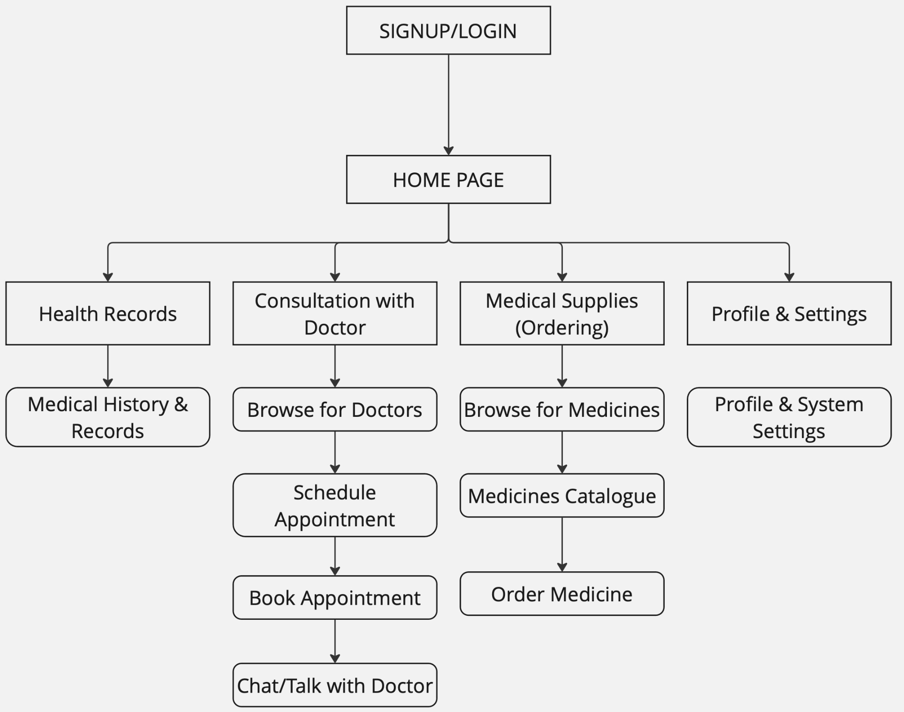

This task flow will be the same in all the Lo-Fi and Mid-Fi Designs. Hence I have put it here.

**Lo-Fi Design (Hand Drawn Sketches)**

Signup Page, Home Screen and Vitals Screen

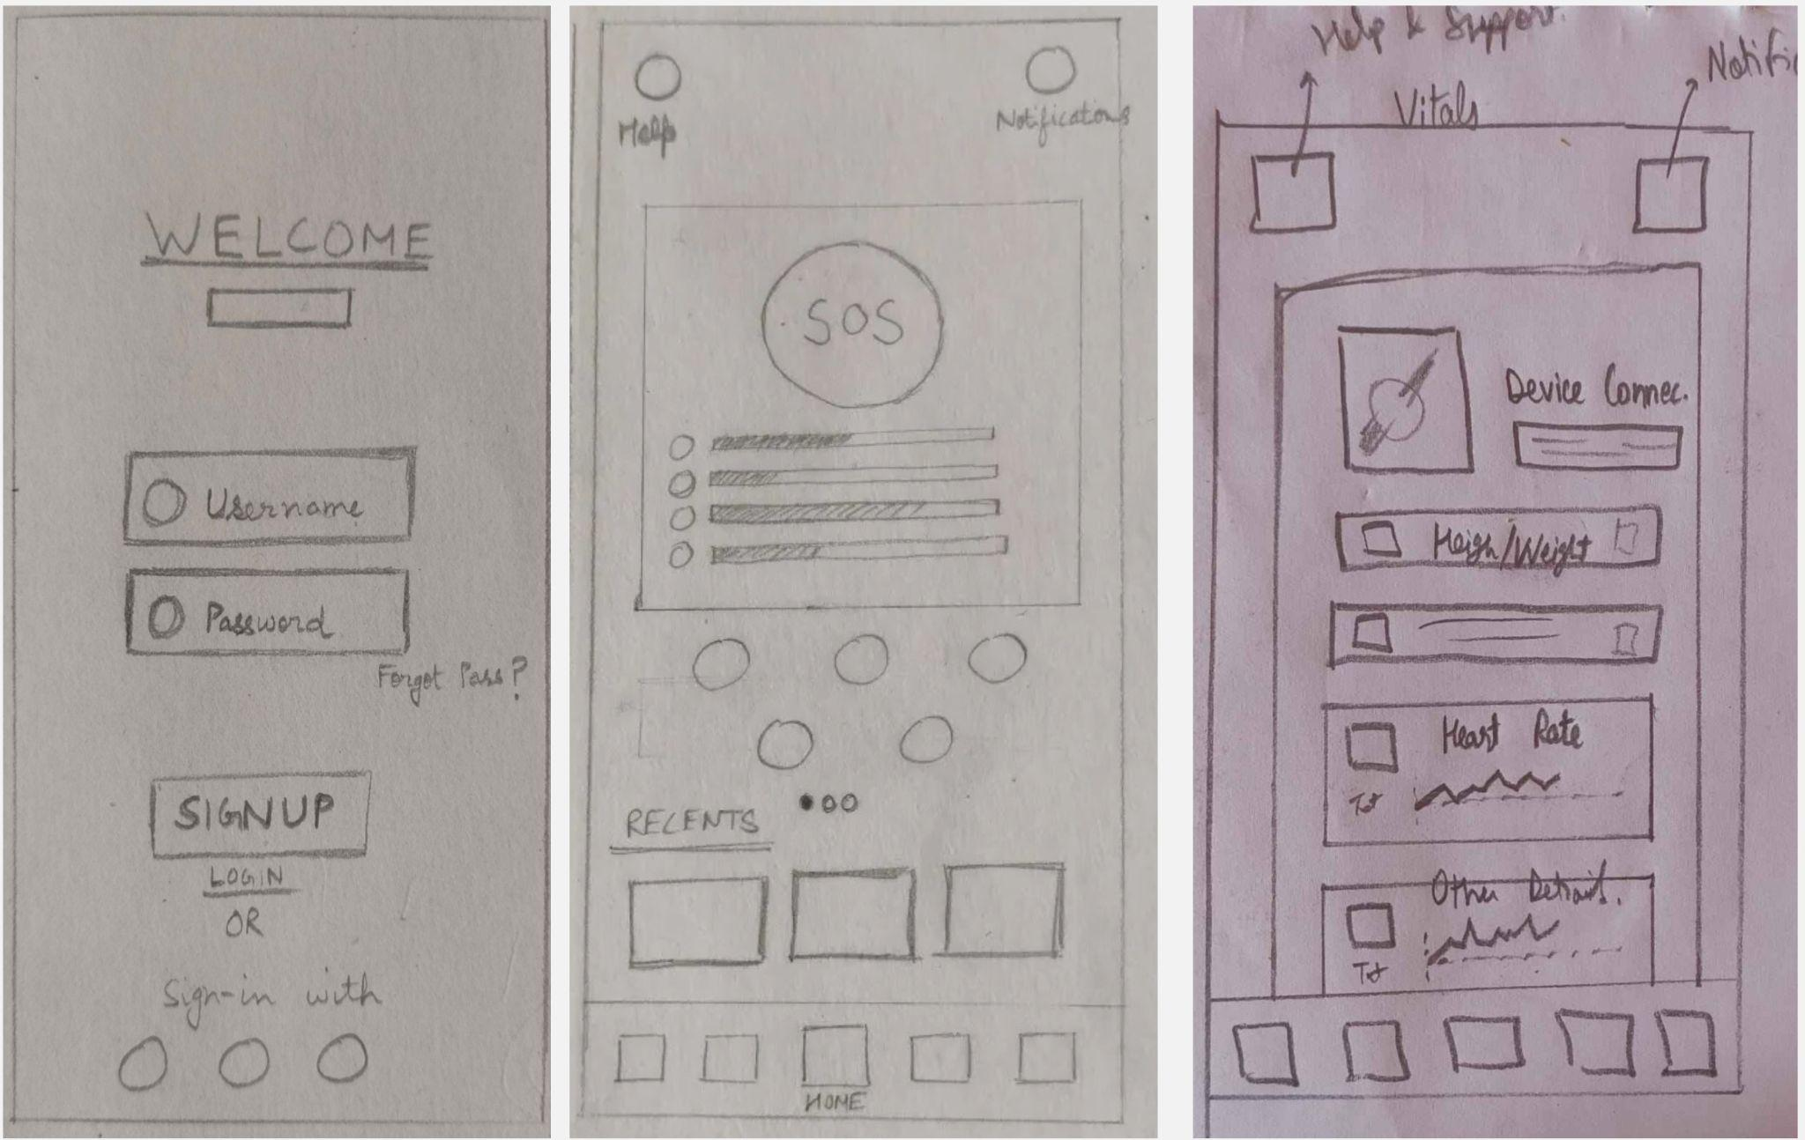

Consultation with Doctors Page

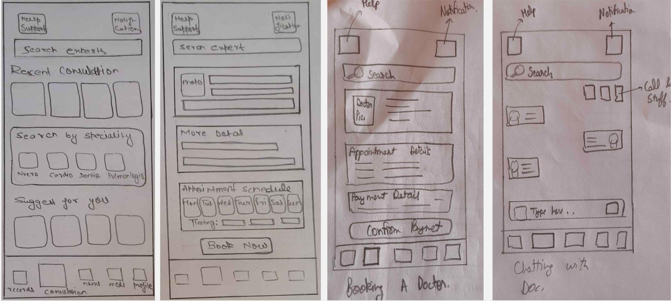

Page to order Medical Supplies

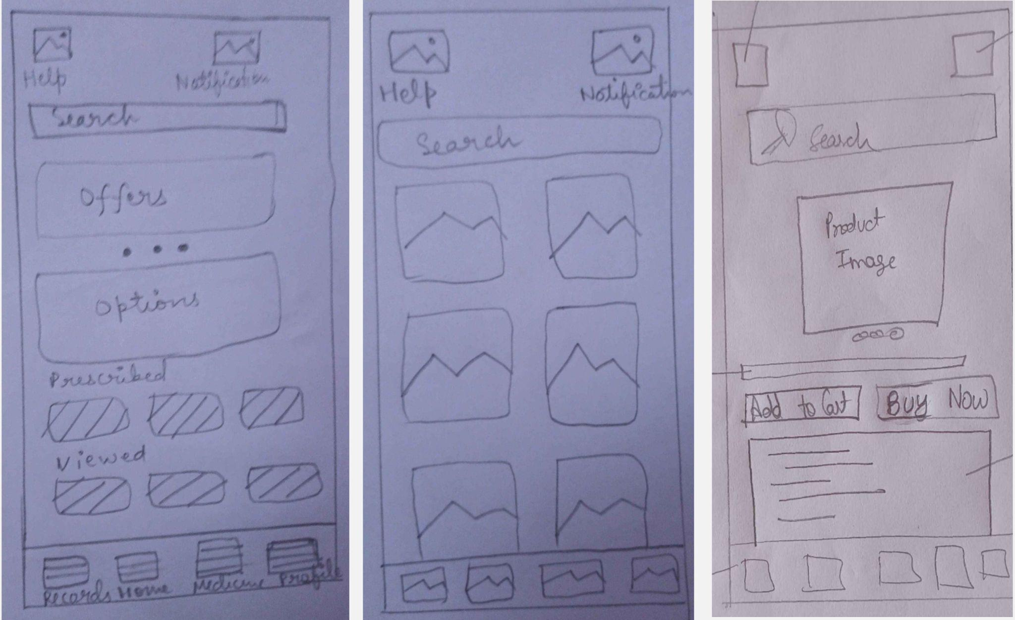

Profile Page & Medical Records Page

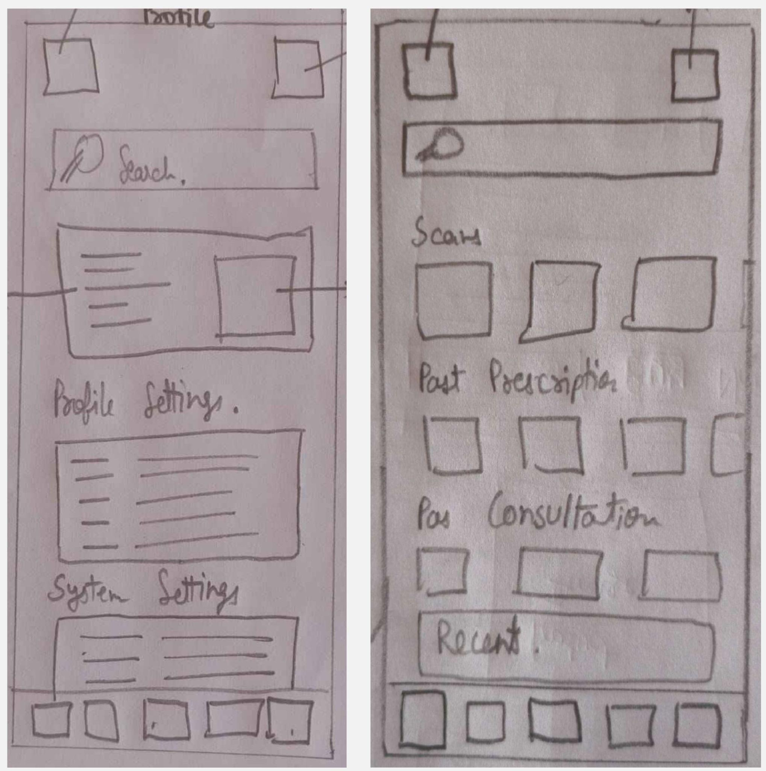

**Mid-Fi Design (Original Figma Design)**

Signup Page, Home Screen and Vitals Screen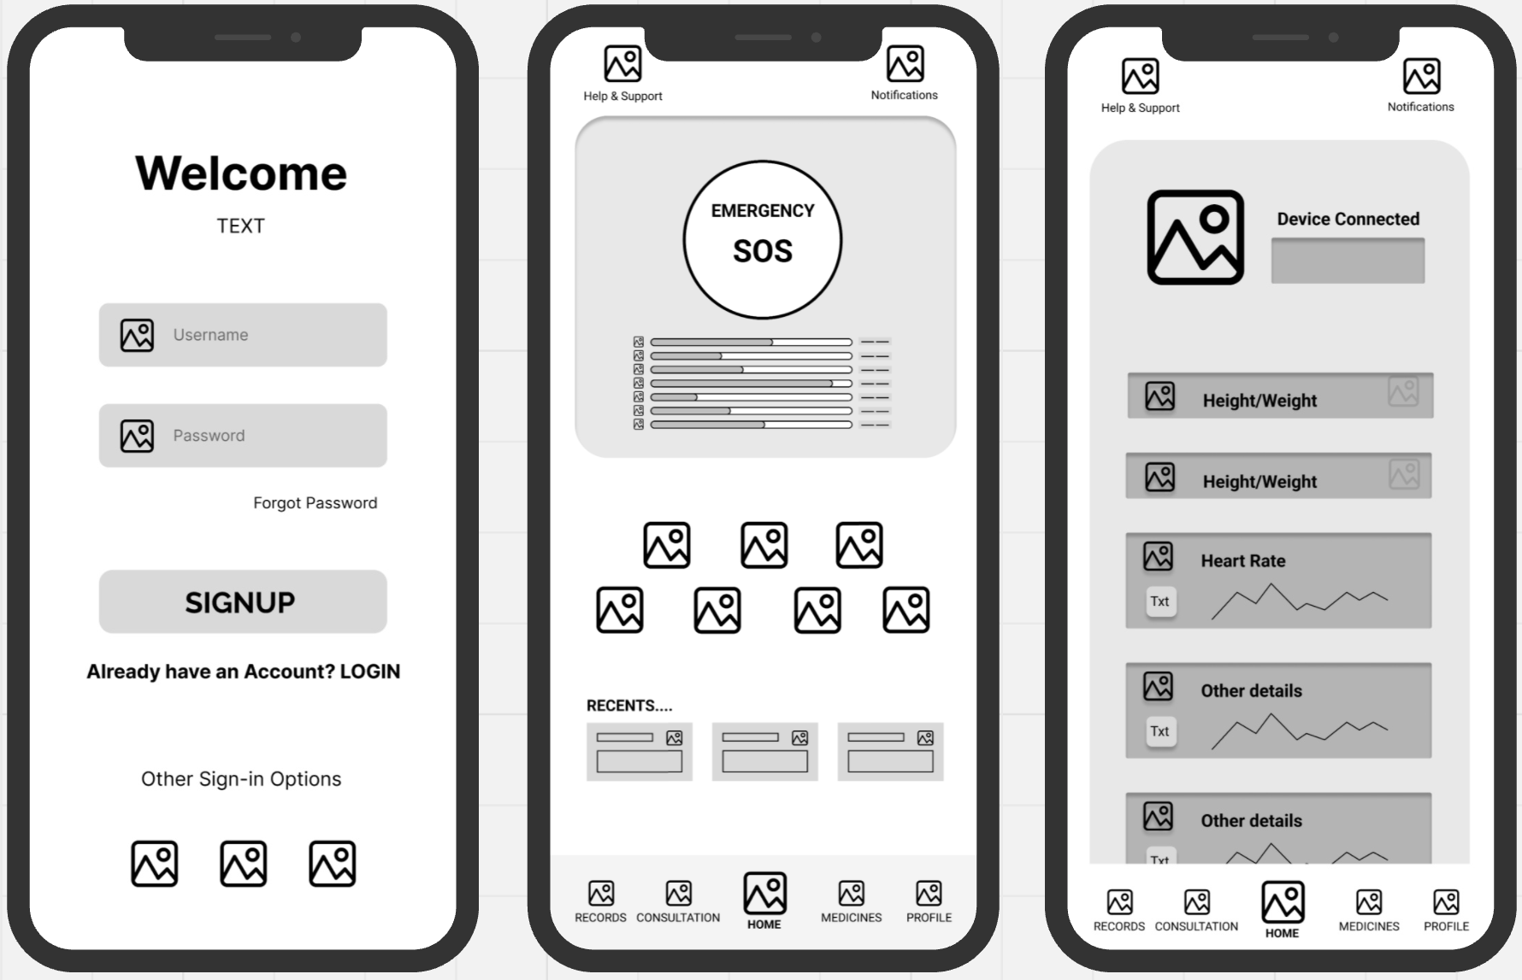

Consultation with Doctors Page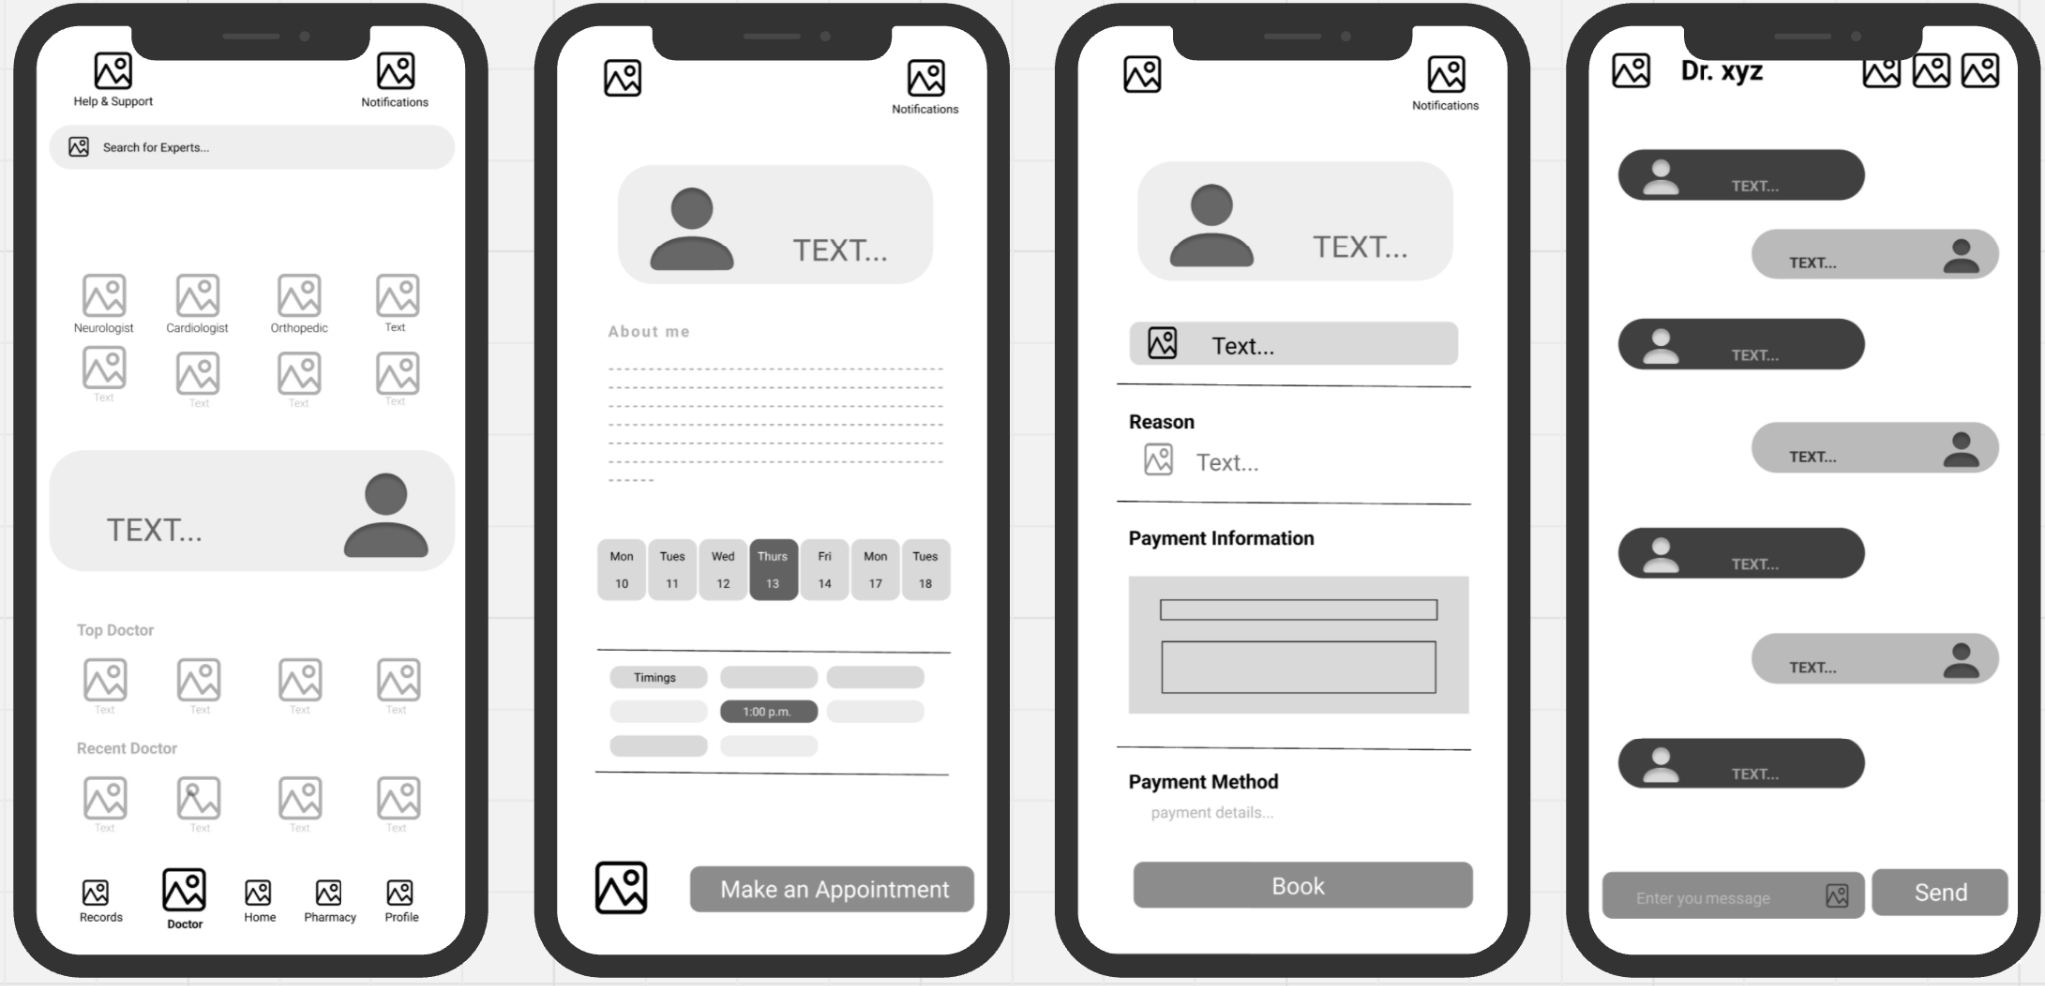

Page to order Medical Supplies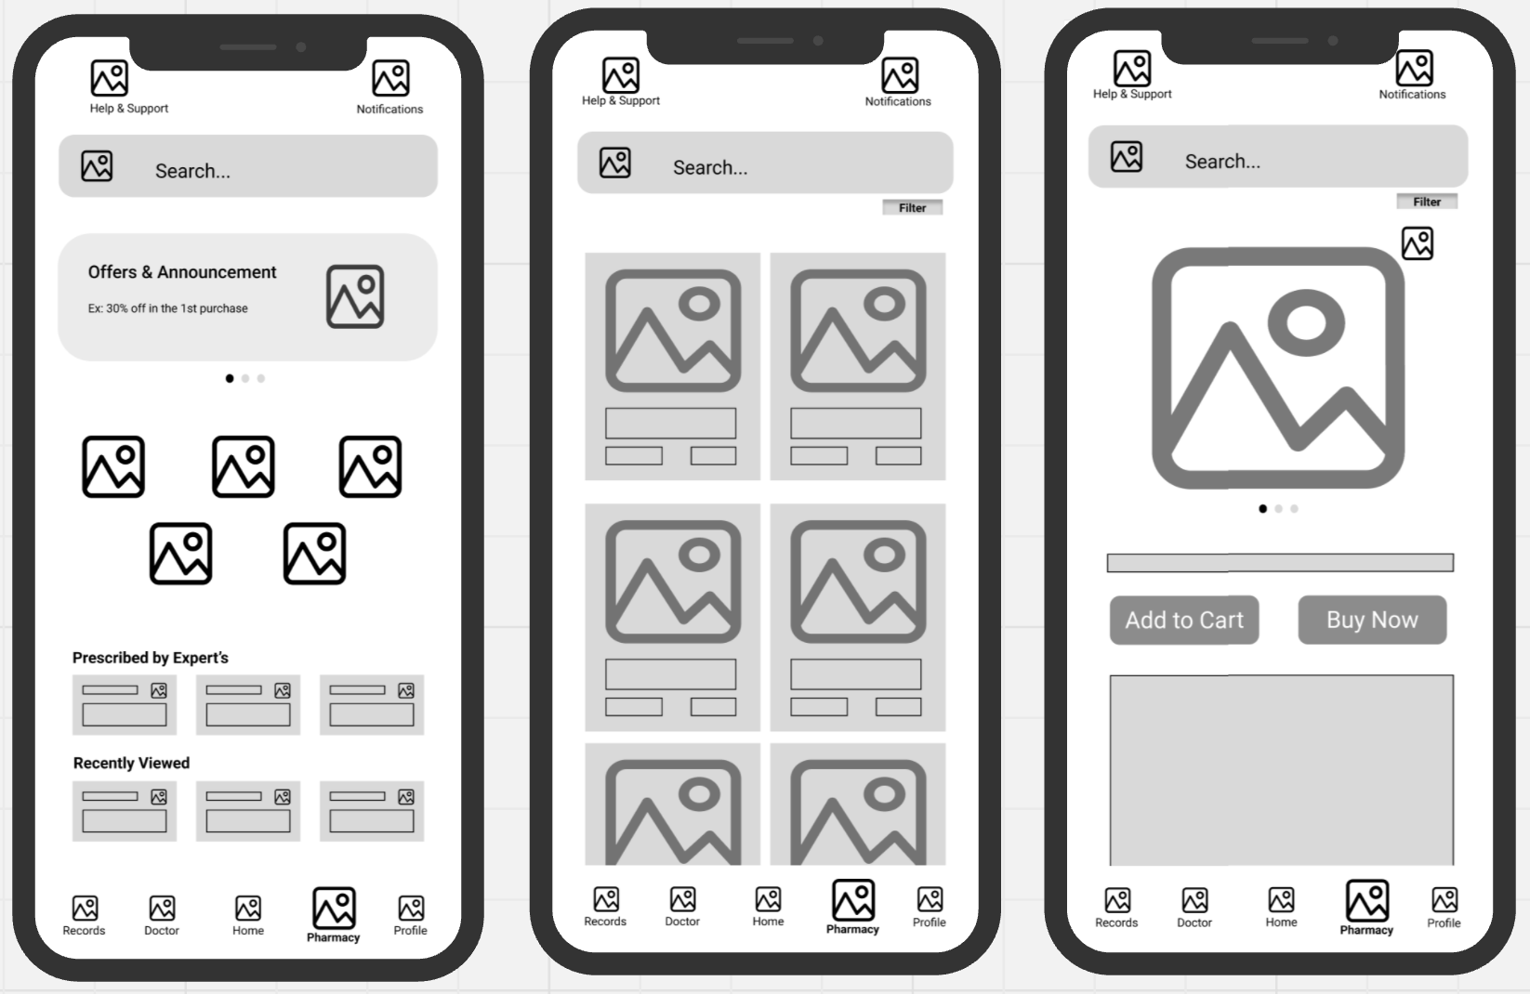

Profile Page & Medical Records Page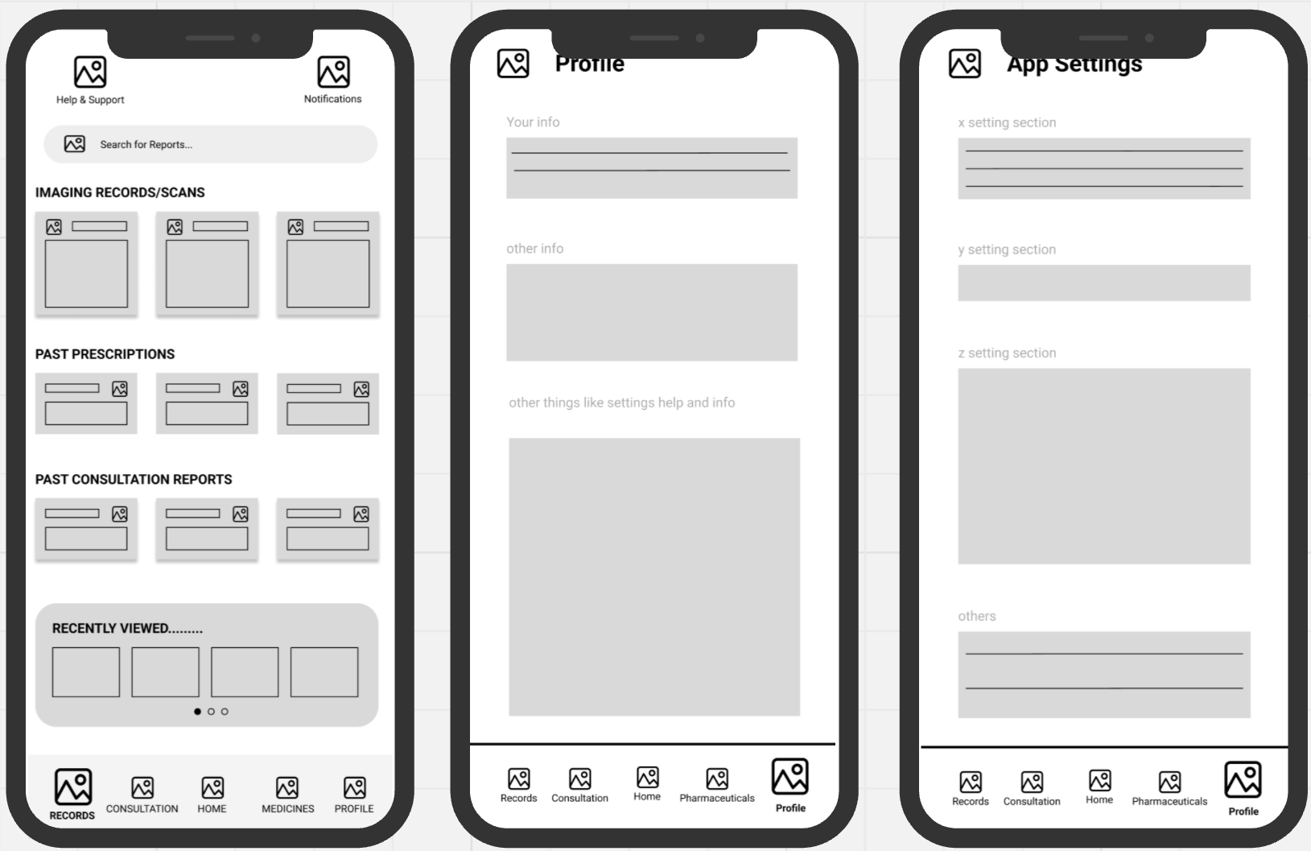

**Features Implemented:**

* **Saids:**
* Health Tracking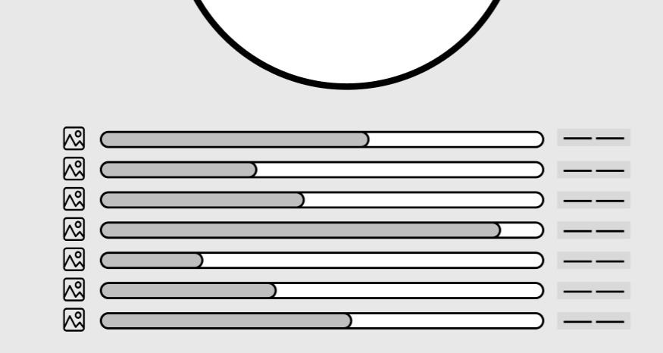

**Have a whole menu (vitals), Plus a preview of vitals on the home screen.**

* Prescription Refill

**Made a whole Pharmacy for any Medical needs with an Option to drone deliveries for remote locations.**

* AI Chatbot

Will be present in the doctor’s section of the app along with other specialised doctors.

* **Suggested:**

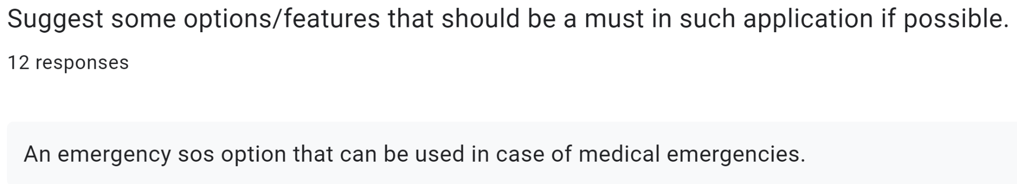

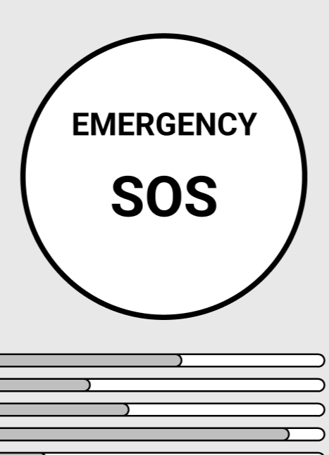

At Home Screen



Have a whole records section for that

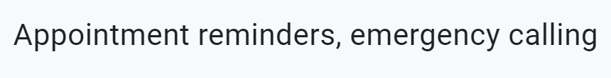

At home screen 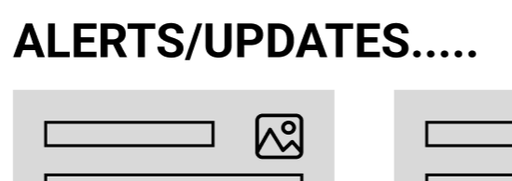

**NOTE: This last one was done after Mid-Fi testing, so it’s not in the Original Mid-Fi Design**

**Google Form and Interview Analysis**

* **General Introductory Questions**

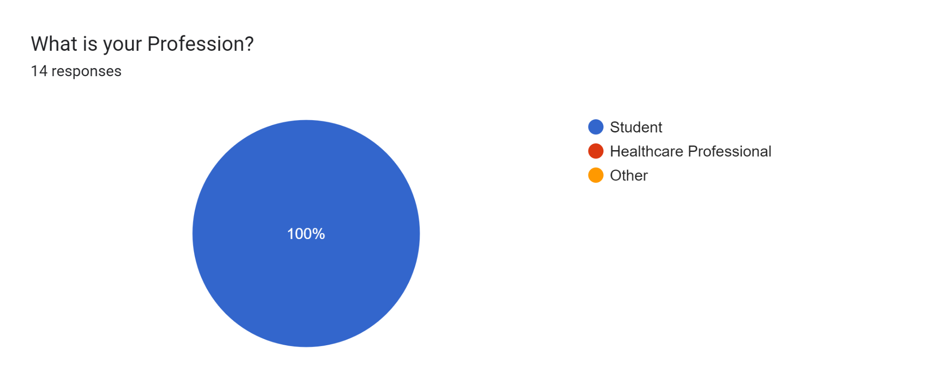

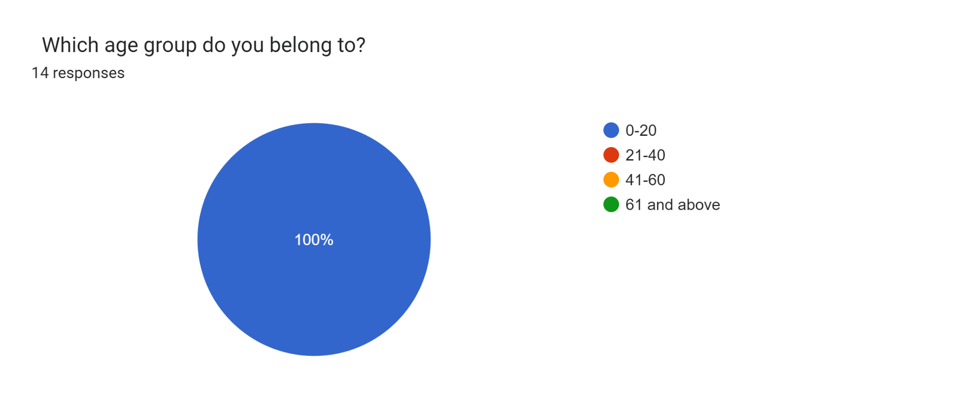

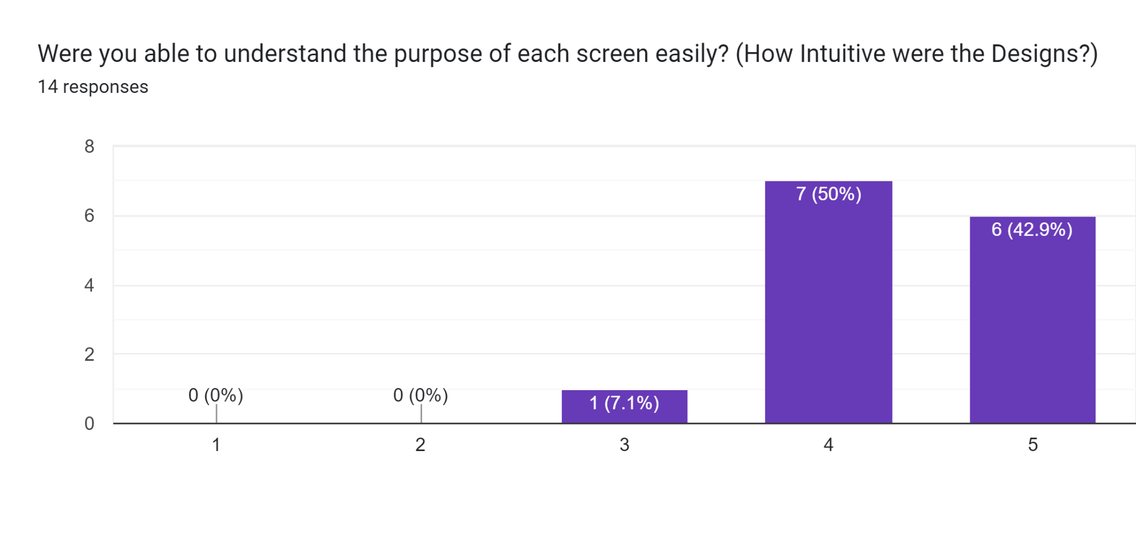

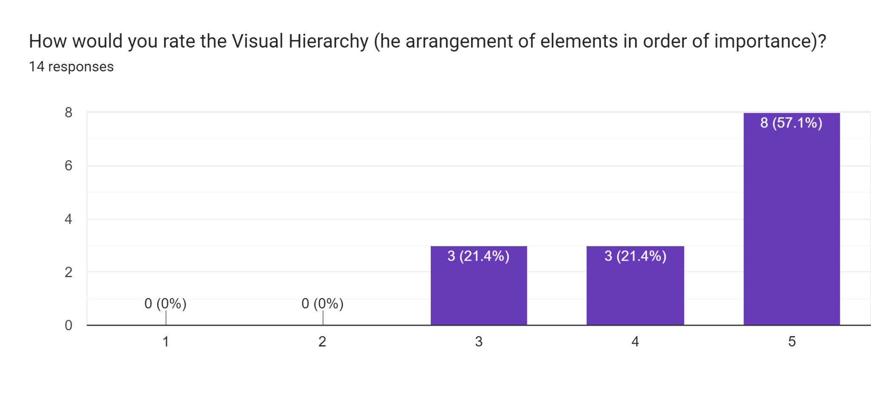

* **Important Questions Regarding Wireframe**

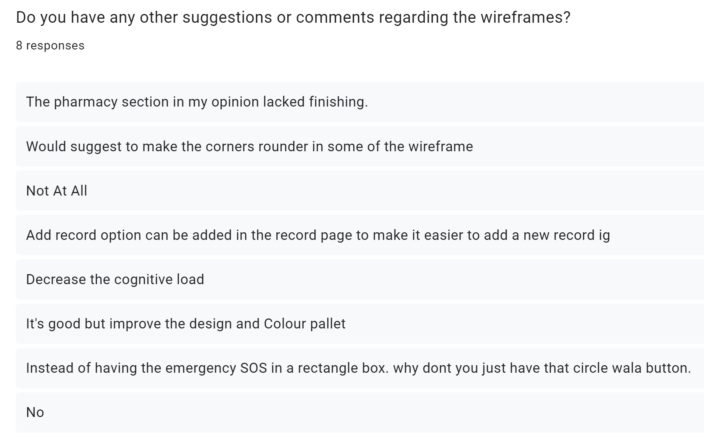  
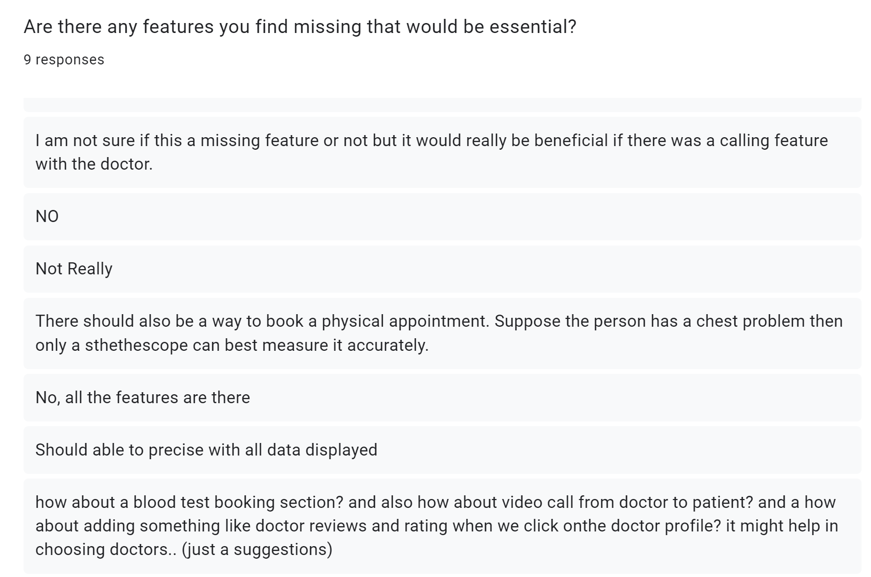’

* **Analysis Report for Survey on Wireframe Designs**

**Overview:**

The survey collected feedback from students in the 0-20 age group, evaluating the wireframes designed for a healthcare monitoring system. The key areas of focus were intuitiveness, visual hierarchy, missing features, and general feedback about the design aesthetics and functionality.

**Survey Data Summary:**

* **Age Group**: All respondents belong to the 0-20 years age group, with "Student" as their profession.
* **Design Intuitiveness:** (Understanding Purpose of Screens): Most respondents rated the wireframes highly in terms of intuitiveness. Around 50% rated it a 5, indicating the designs were easy to understand.
* **Visual Hierarchy:** (Arrangement of Elements): Responses were more varied here, with ratings spanning from 3 to 5. Some feedback suggests minor improvements in visual hierarchy could be beneficial.
* **Design Ratings**: The average rating given to the designs is around 4. Many respondents are satisfied with the current layout, though there are suggestions for enhancements.

**Key Feedback Themes:**

* **Missing Features & Suggestions**
* **Doctor Calling Feature**: A couple of respondents suggested adding a feature to allow direct communication with doctors, either via voice or video calls.
* **Blood Test Booking**: Another suggestion was to include a section where users could book blood tests or other medical tests directly through the app.
* **Adding Records**: One participant recommended adding an easier way to add new records in the system, perhaps a button within the record page.
* **Physical Appointment Booking**: One respondent highlighted the importance of being able to book physical appointments for conditions that require in-person diagnostics (e.g., chest problems that need a stethoscope examination).
* **Doctor Ratings and Reviews**: It was suggested to add a feature allowing users to see reviews and ratings for doctors to help in selecting a suitable healthcare provider.
* **Design Improvements:**
* **Finishing and Detail Refinement**: Some respondents pointed out that certain sections, like the pharmacy section, lacked polish or finishing and also mentioned about improving the aesthetics, such as making the corners rounder.
* **Cognitive Load**: One respondent mentioned decreasing cognitive load by simplifying data display.

**Conclusion:**

In conclusion, the survey results show that the wireframes are generally intuitive and well-received, with high ratings for design and usability. However, there are suggestions for adding features like doctor calls, appointment booking, and doctor reviews, as well as refining visual elements and improving the aesthetic polish. Implementing these changes will enhance both functionality and user experience.

**Alternate Designs(Improvised & Final)**

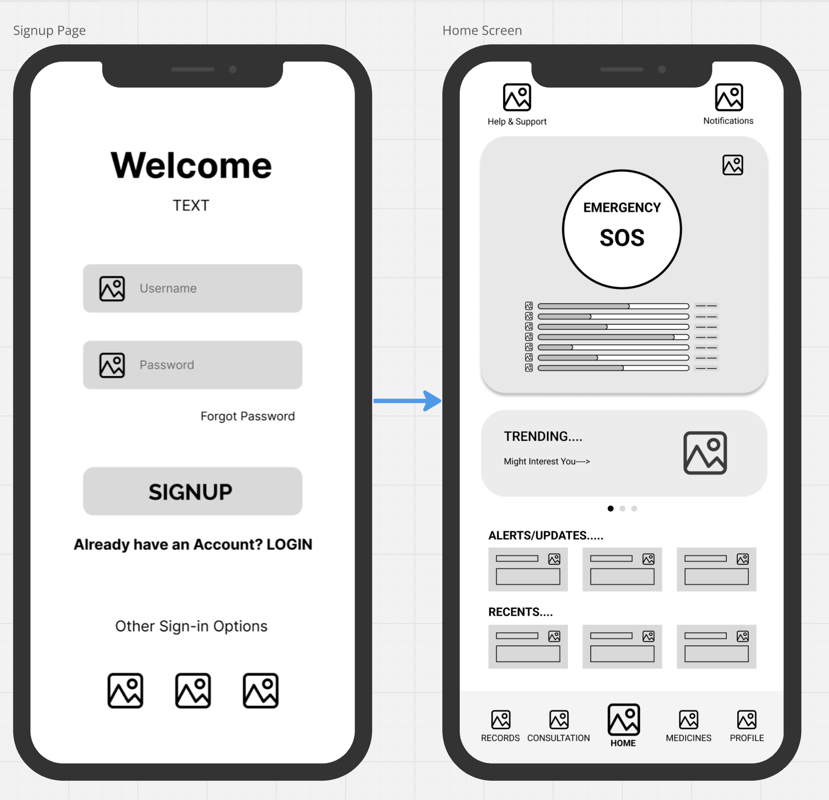

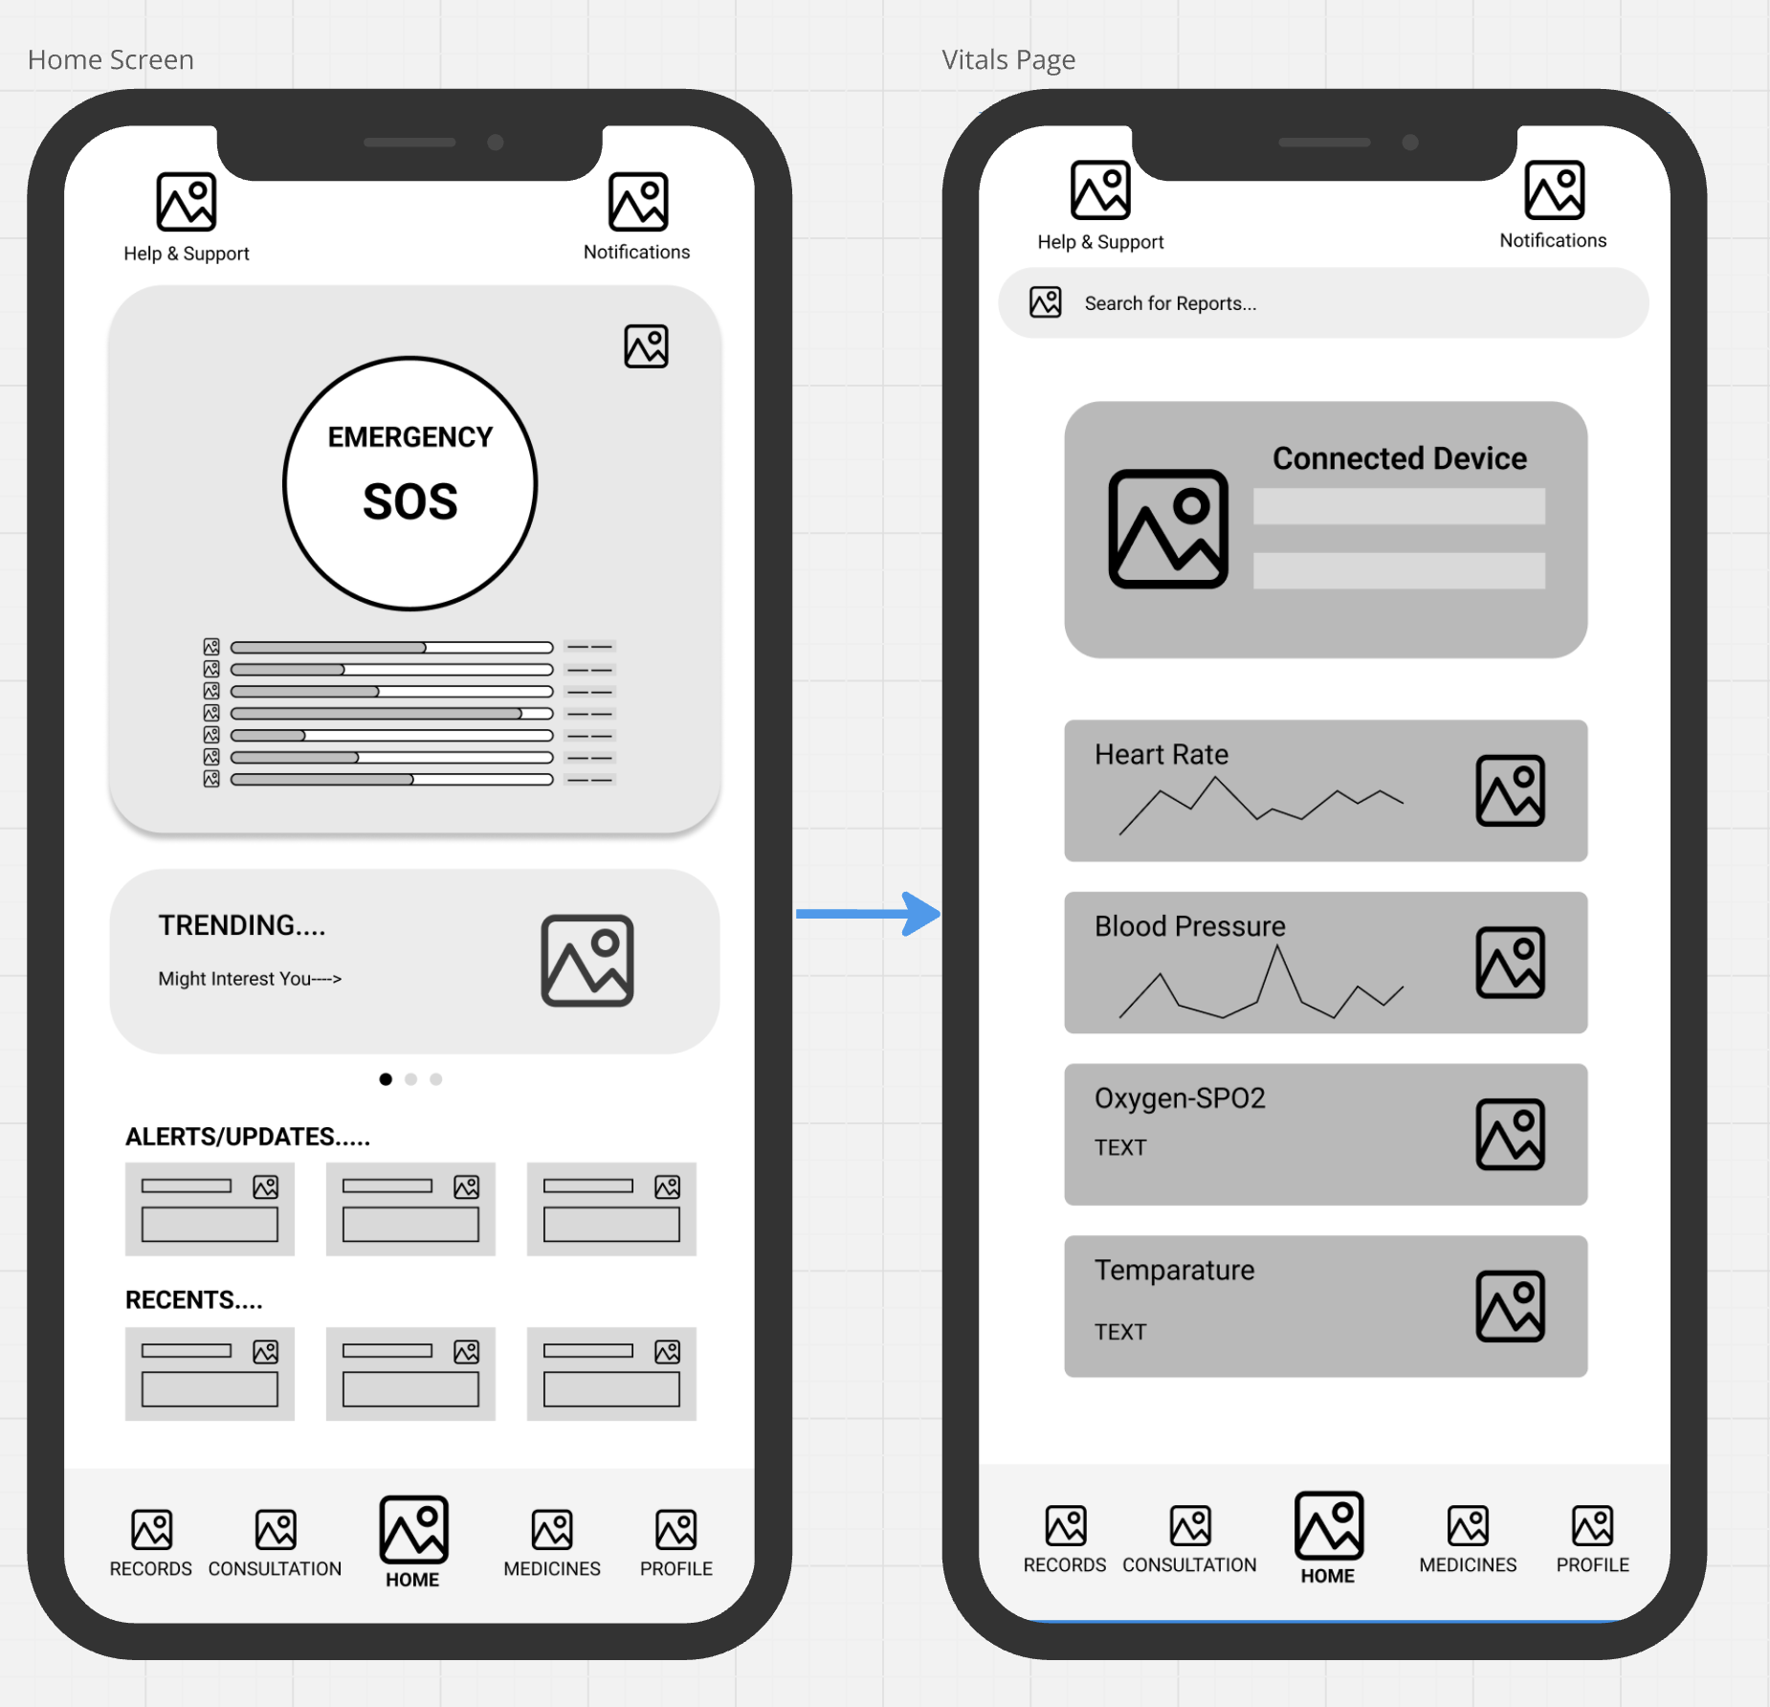

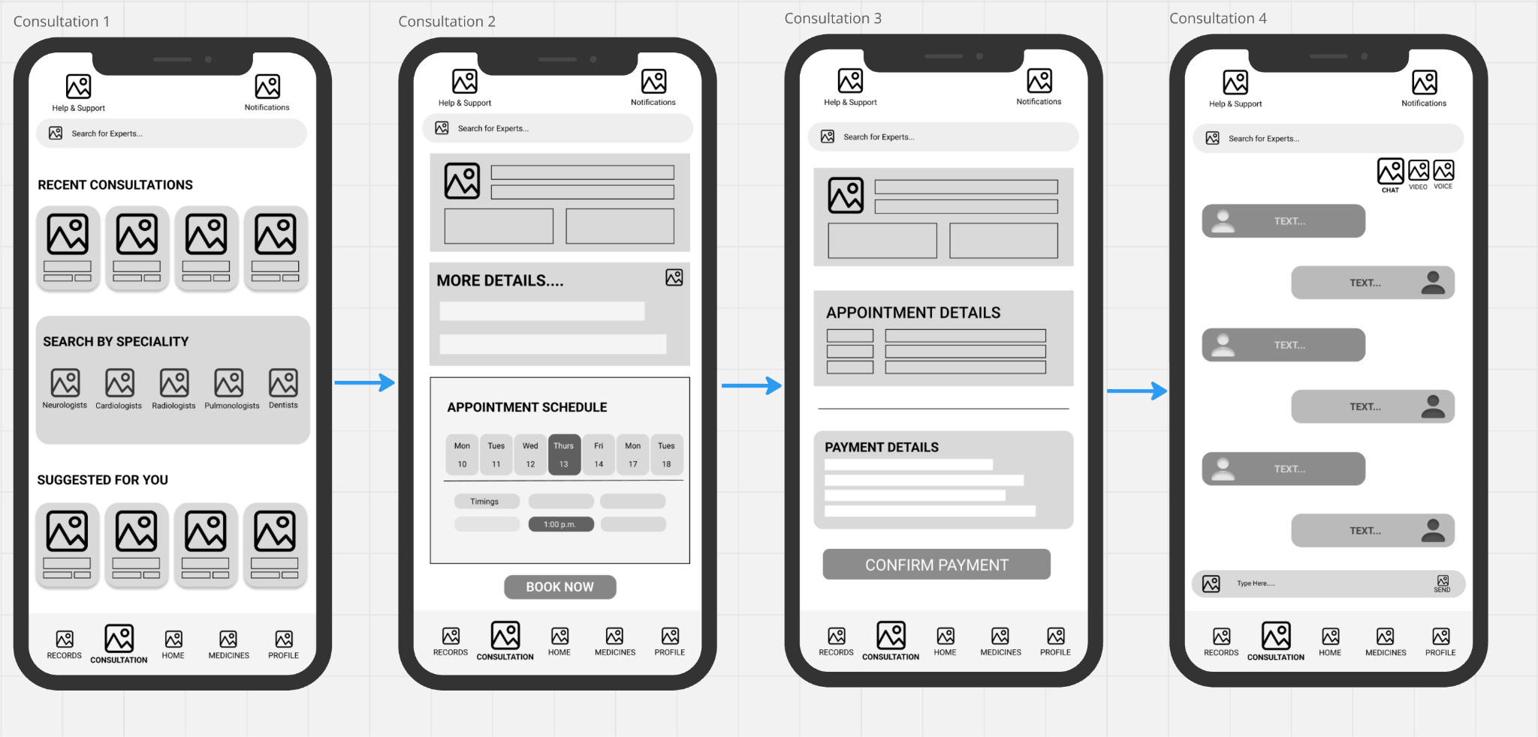

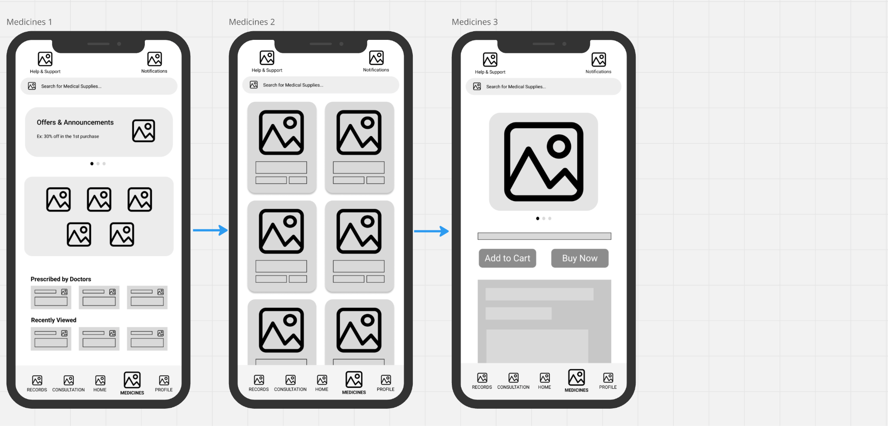

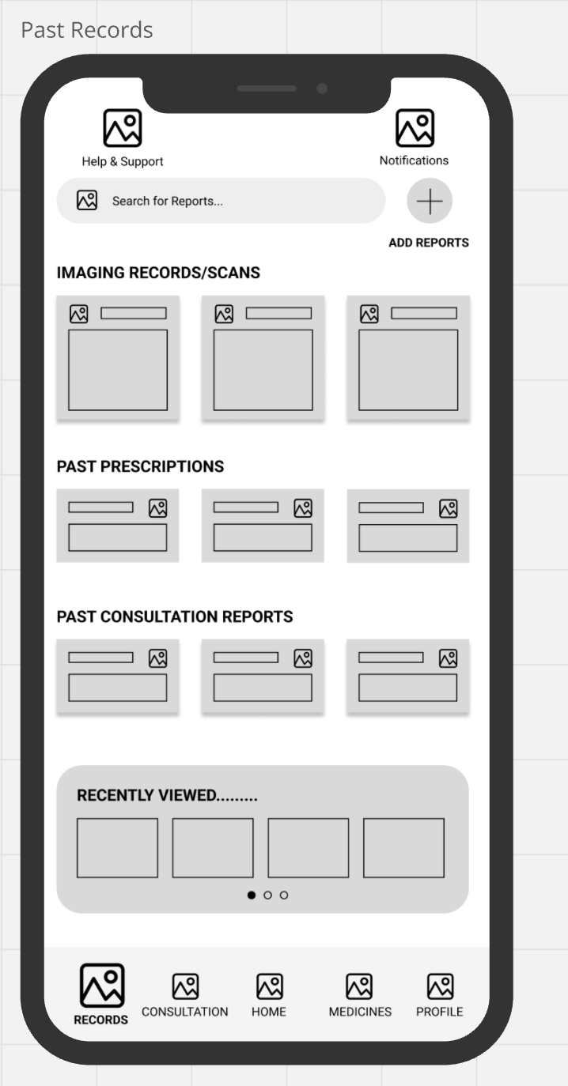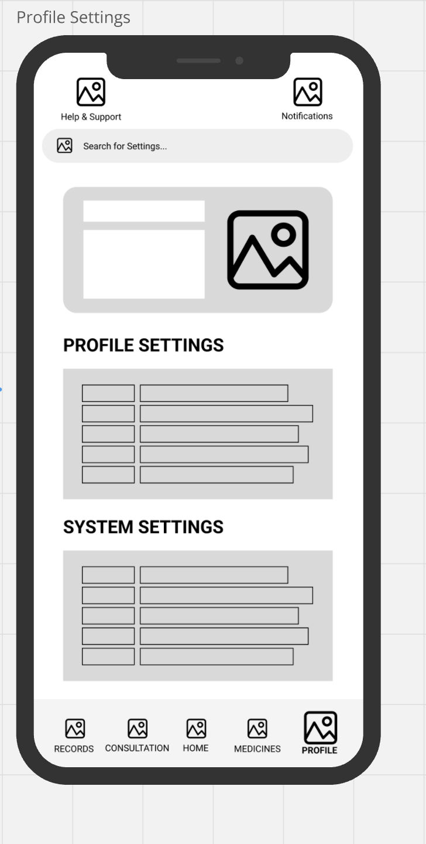

**Suggestions & Features Implemented:**

* **Doctor Calling Feature**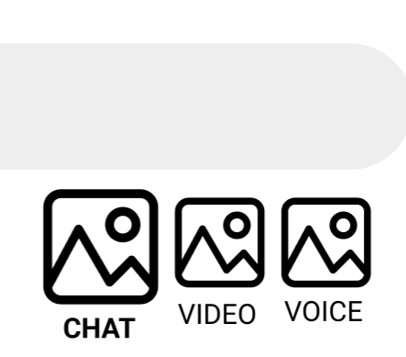

**(Added in the chat box)**

* **Adding Medical Records (Scans, Physician Reports etc.)**

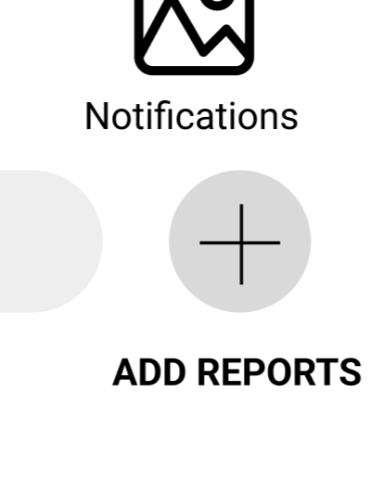

**(Added in records next to the search bar)**

* **Doctor Ratings and Reviews**

**The rating part will be shown in the suggested doctors part of the application and the reviews will be shown in more details section of the application**

* **Finishing Touches & Reducing Cognitive Load**

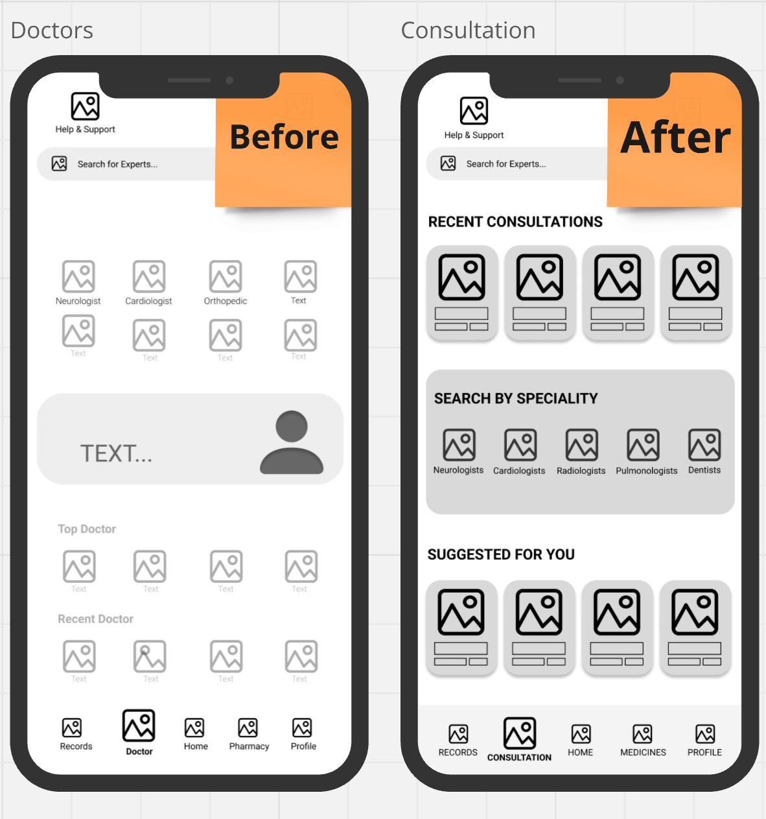

* **Future Implementation:** Booking for Physical Appointments and Tests through the Application Itself (Will be included in the final Hi-fi)

**Links:**

* **Figma (Mid-Fi):**

[**https://www.figma.com/design/m15Ww8bWzmLsPeqj2IaN8t/PreCure.WireFrame?node-id=0-1&t=ZDlPA07r6kSw5pgu-1**](https://www.figma.com/design/m15Ww8bWzmLsPeqj2IaN8t/PreCure.WireFrame?node-id=0-1&t=ZDlPA07r6kSw5pgu-1)

* **Miro(MentalModel,Use-CaseDiagram,Personas, Scenarios,Task-flow,Brainstorming,Mid-Fi):**

[**https://miro.com/welcomeonboard/anNHM044YVNjS1JtejRGbUtrTEdjb2RCQ1ByUGtHU3ZLek5sR0NqVktXSmVObVl5cnR3VVM5emFkSjVFNGJYMXwzNDU4NzY0NjAzNzk0MjYyNTUzfDI=?share_link_id=881725856044**](https://miro.com/welcomeonboard/anNHM044YVNjS1JtejRGbUtrTEdjb2RCQ1ByUGtHU3ZLek5sR0NqVktXSmVObVl5cnR3VVM5emFkSjVFNGJYMXwzNDU4NzY0NjAzNzk0MjYyNTUzfDI=?share_link_id=881725856044)

* **Requirement Gathering Survey (Google Form):**

[**https://forms.gle/YMTCXxh7LNq2JNQ46**](https://forms.gle/YMTCXxh7LNq2JNQ46)

* **MidFi Testing Survey(Google Form):**

[**https://forms.gle/E8iMUnFC8jDT2Fvm8**](https://forms.gle/E8iMUnFC8jDT2Fvm8)

* **Interview Video with Doctor:**

[**https://drive.google.com/file/d/1RvRVYvBKqrZ4bfcrGNjszG90LaXUurxZ/view?usp=sharing**](https://drive.google.com/file/d/1RvRVYvBKqrZ4bfcrGNjszG90LaXUurxZ/view?usp=sharing)

**Individual Contributions:**

* **Arsh**
* Scenarios
* Brainstorming & Problem Understanding
* **Aryan**
* Requirement Gathering Survey
* Mental Model
* Use Case Diagram
* **Bhavay**
* Personas
* Challenges
* **Daksh**
* MidFi Design
* MidFi Testing
* Compilation & Finishing
* **Dhruv**
* Alternate MidFi Design
* Compilation & Finishing
* Task-Flow
* **Divyeh**
* Requirement Gathering Survey Analysis
* Interview

**Note: We all Contributed equally on Low-Fi Design (Hand-Drawn Sketches)**